Project Title

Hospital Online Appointment System (Darm $\acute{a}$ n)



Author

|  |  |
| --- | --- |
| Sangeen Murad | 1108494 |
| Meena Yasin | 1107707 |
| Shahgul Bashir | 1108084 |
| Maryam Faiz | 1107476 |

Supervisor

Mr. Abdul Hakeem

DEPARTMENT OF COMPUTER SCIENCE

FACULTY OF SCIENCE AND ENGINEERING

UNIVERSITY OF TURBAT

December, 2025

# Project Title

DARM $\acute{A}$ N*(Hospital Online Appointment System)*

Author

|  |  |
| --- | --- |
| Group Leader Name | Sangeen Murad |
| Student-1 Name | Meena Yasin |
| Student-2 Name | Shahgul Bashir |
| Student-3 Name | Maryam Faiz |
| Program and Batch: | BSCS (2022-2025) |

A report submitted in partial fulfillment of the requirements for the degree of

**BS Computer Science**

Supervised By

**Mr. Abdul Hakeem**

Department of Computer Science

University of Turbat

Turbat, Kech

Head of The Department Signature:

Supervisor Signature: _____________________________

External Member Signature

DEPARTMENT OF COMPUTER SCIENCE

FACULTY OF SCIENCE AND ENGINEERING

UNIVERSITY OF TURBAT

January, 2025

# DEDICATION

We dedicate this project in the name of Allah the Almighty who is present when we are planning and whose preciseness fulfills our dream. Special dedication also to our parents, whose prayers, love, support and motivation are with us in each moment of life. Furthermore, we love to dedicate our respected teachers of the department, best friends, supportive students of UOT and all class fellows for the continual impact of knowledge. Finally, we dedicate our supervisor and the Head of the Computer Science department for their motivation and support.

# UNDERTAKING

I certify that the research work titled “*Hospital Online Appointment System*” is my own work. The work has not been presented elsewhere for assessment. Where material has been used from other sources it has been properly acknowledged/referred.

|  |  |  |  |
| --- | --- | --- | --- |
| Sr.# | Name of Student | Reg. # | Signature |
| 1 | Sangeen Murad | 1108494 |  |
| 2 | Meena Yasin | 1107707 |  |
| 3 | Shahgul Bashir | 1108084 |  |
| 4 | Maryam Faiz | 1107476 |  |

# ACKNOWLEDGMENTS

Thanks to Allah the Rahman and merciful whose help for all over the universe, whose powers are indefinable and who helps us to complete our project under Mr. Abdul Hakeem’s supervision and his encouragement and guidance. We are incredibly grateful to our supervisor for his vision and his persistence upon the values of hard work on this project. Without him it may not be possible to complete this project within the limited duration. We would also respect all other faculty of the computer science department for their support and given time.

Furthermore, it has been a beautiful journey with our classmates and faculty of computer science department and others as well. Lastly, we would like to thank our institute, University of Turbat, for providing us a platform to make such a project within the Turbat environment. This would not have been possible without it.

Contents

Project Title 2

DEDICATION 3

UNDERTAKING 4

ACKNOWLEDGMENTS 5

ABSTRACT 11

CHAPTER 1: INTRODUCTORY CHAPTER 12

1.1 Introduction 12

1.1.1 Purpose 12

1.1.2 Description 13

1.1.3 Product Scope 13

1.1.4 Gantt chart 14

1.1.5 Objective 14

1.1.6 Problem Statement 15

1.1.7 Functional Requirements 15

1.1.8 Non-Functional Requirements 17

1.1.9 Intended Audience and Reading Suggestions 18

1.2 Overall Description 18

1.2.1 Product Perspective 18

1.2.2 Product Feature 19

1.2.3 User Classes and Characteristics 20

1.2.4 Operational Environment 20

1.2.5 Assumptions and Dependencies 21

1.3 External Interface Requirement 21

1.3.1 User Interface 22

1.3.2 Internet Connectivity 22

CHAPTER 2: LITERATURE REVIEW 23

2.1 Introduction 23

2.2 Existing Solution 23

2.2.1 Mahram 23

2.2.2 Oladoc 24

2.2.3 Healthwire 24

2.2.4 Sehat Kahani 24

2.2.5 InstaCare 24

CHAPTER 3: METHODOLOGY 25

3.1 Methodology for development 25

3.1.1 Introduction 25

3.1.2 Design Phase 26

3.1.3 Implementation phase 26

3.1.4 Testing phase 26

3.2 System Architecture 27

3.3 Hardware and Software Requirement 28

3.3.1 Hardware Requirement 28

3.3.2 Software Requirements 29

3.4 Use Case diagram 30

3.5Final Interface 31

3.5.1 Splash Screen 32

3.5.2 login Screen 33

3.5.3 Forgot Password Screen 34

Description: 34

3.5.4 OTP Verification Screen 36

Description: 36

3.5.5 Patient Screen 37

3.5.5 Sign Up Screen 38

Description: 38

3.5.6 Doctor List Screen 39

3.5.7 Patient Information Screen (Appointment Booking) 40

3.5.8 Payment Method Screen 42

3.5.9 Appointment Confirmed Screen 42

Description: 42

3.5.10 Edit Profile Screen 45

Description: 45

3.5.11 Change Password Screen 46

3.5.12 Notification Screen (Patient) 47

Description: 47

3.5.13 Feedback Screen 50

Description: 50

3.5.14 Admin Dashboard Screen 52

3.5.15 Manage Doctor Screen 53

3.5.16 Other Admin Screens (as per screenshots) 54

3.5.17 Doctor Dashboard Screen 71

3.5.18 Patient List Screen 72

3.5.19 Doctor Profile Screen 73

3.5.20 Doctor Leave Request Screen 74

3.5.21 Doctor Setting Screen 76

CHAPTER 4: IMPLEMENTATION 77

4.1 Overview 77

4.1.1 Key Features 77

4.2 System Overview 78

4.2.1 User Interface 78

4.2.2 Authentication and Security 78

4.2.3 Appointment Processing 78

4.2.4 Appointment Fee Management 78

4.2.5 Schedule Management 78

4.2.6 Notification System 78

4.3 Technologies and Tools Used 79

Tools/technologies 79

versions 79

motive 79

Flutter 79

3.x 79

Framework 79

Dart 79

3.x 79

Programming language 79

Supabase 79

latest 79

Database 79

Figma 79

latest 79

Design 79

Android studio 79

latest 79

IDE 79

CHAPTER NO 5: CONCLUSION 80

Problems Faced 80

Future Work of Darm $a$ n 80

REFERENCES 81

ABBREVIATIONS 81

List of Tables:

|  |  |  |
| --- | --- | --- |
| 1 | Splash Screen | Figure: 3.5.1 |
| 2 | Login | Figure: 3.5.2 |
| 3 | Forget Password | Figure: 3.5.3 |
| 4 | OTP Pop Up | Figure: 3.5.4 |
| 5 | OTP Verification | Figure: 3.5.5 |
| 6 | Patient Screen | Figure: 3.5.6 |
| 7 | Sign Up | Figure: 3.5.7 |
| 8 | Doctor List | Figure: 3.5.8 |
| 9 | Patient Information | Figure: 3.5.9 |
| 10 | Payment / Billing | Figure: 3.5.10 |
| 11 | Appointment confirm | Figure: 3.5.11 |
| 12 | Edit Profile | Figure: 3.5.12 |
| 13 | Change Password | Figure: 3.5.13 |
| 14 | Notifications | Figure: 3.5.14 |
| 15 | Feedback | Figure: 3.5.15 |
| 16 | Admin Dashboard | Figure: 3.5.16 |
| 17 | Manage Doctor | Figure: 3.5.17 |
| 18 | Doctor Dashboard | Figure: 3.5.19 |
| 19 | Patient List | Figure: 3.5.20 |
| 20 | Doctor Profile | Figure: 3.5.21 |
| 21 | Doctor Leave Request | Figure: 3.5.22 |
| 22 | Settings | Figure: 3.5.23 |

# ABSTRACT

The Online Hospital Appointment System is a mobile application designed to make the booking and management of hospital appointments simpler and digitized. The key aim of this project is to ensure that the traditional manual appointment system is replaced with one that is efficient, user-friendly, and time-saving. Through this system, patients will be able to register themselves easily, see the lists of available doctors, view their respective schedules, and book their appointments as per their convenience without having to physically go to the hospital.

The system also offers a structured interface for doctors and hospital staff to manage appointments, view patient details, and update their availability in real time. Administrators can oversee the overall system operations: managing patient records, doctor information, and appointment data.

By implementing the Online Hospital Appointment System, hospitals can minimize waiting times, reduce administrative workload, and improve the overall quality of healthcare services. The system ensures secure data handling, quick communication between patients and doctors, and improved accessibility through a digital platform. Ultimately, this project aims to enhance hospital efficiency and patient satisfaction by providing a convenient and reliable online appointment management solution.

# CHAPTER 1: INTRODUCTORY CHAPTER

## 1.1 Introduction

In this digital world of today, technology has changed almost every aspect of human life, Including health care. The old and traditional method of booking appointments in hospitals was slow and difficult for patients who had to go to hospital and stand in line for booking appointment and wait for their turn, in case if the doctor was absent they had to come home back without doctor checkup. Due to these issues hospital can now use digital systems that make it easy to book and manage appointments, now patients don’t need to physically go to hospital for booking appointment, they can book appointment at home by this application.

Our project introduces an **Online Hospital Appointment System(**Darm $\acute{a}$ n**)** that helps make the process of booking, managing and tracking appointments simple and efficient. With this system, patients can book appointments with doctors online without visiting the hospital or filling out forms manually. Patients can see the availability of doctors, can choose date and time suitable for them and get immediate confirmation. The hospital staff will have easier management of appointments, avoiding overcrowd and allowing better planning of their schedules. The system provides secure login, data encryption and proper database management to protect patient data.

### 1.1.1 Purpose

The purpose of Darm $\acute{a}$ n is to improve the old way of booking hospital appointment system secure, easy and fast by offering an online system for patients and doctors. This system ends the need for patients to physically visit hospital for booking appointments, it reduces time and reduce long waiting hours. The main purpose of Darm $\acute{a}$ n is to make a paperless and well managed appointment environment that will enhance healthcare service delivery and focusing on increasing the efficiency of management.

This project introduces a user-friendly online platform that ensures an easy navigation and easy access for patients, doctors and administration alike. Patients can easily create their account, login securely and book appointments with their preferred doctors by this system at their home.

Furthermore, **Darm $\acute{a}$ n** focuses on different key objectives and benefits which improve hospital workflow, ensuring patient data security, reduce overcrowding and promoting digital healthcare practices within the hospital.

#### Improved Appointment Management

With Darm $\acute{a}$ n, appointment booking and management becomes simpler. Patients easily get to see the available doctors, select dates and time accordingly and get instant confirmations are sent back. This ends up the manual workload for hospital staff and saves time for both patients and the doctors.

#### Enhanced Healthcare Efficiency

By automating the appointment process, the system minimizes human mistakes and make hospital appointments automatic. It reduces overcrowding in waiting areas and allows doctors to manage their daily schedules more effectively, resulting in faster and more organized patient care.

#### Environmental Sustainability

By making the manual booking appointments digital reduces the dependency on paper based records and use of manual forms which helps support environment sustainability by paper waste and also encouraging an eco-friendly technology based healthcare environment.

#### Secure Patient Data

This system include advance security features like secure login credentials and database protection that safes the patient information from getting accessed through unauthorized sources such measures maintain privacy between the patients and the healthcare system.

In conclusion, the Darm $\acute{a}$ n **(Online Hospital Appointment System)** plays a vital role in providing a reliable, secure, and time-saving solution for both patients and hospital staff. It enhances efficiency, ensures data protection, supports digital transformation in healthcare, and contributes to a more sustainable and organized hospital environment.

### 1.1.2 Description

The Darm $\acute{a}$ n (Online Hospital Appointment System) is a digital that helps to ease and enhance the appointment-booking process in hospitals. It offers an easy, secure and efficient process by which patients can plan appointments with doctors without physically going to the hospital. This system allows patients to book, manage, and cancel appointments online, reducing congestion and waiting time within hospitals.

Darm $\acute{a}$ n is designed with a user-friendly interface that will enable patients to create their accounts, log in securely, and choose a doctor and preferred appointment time. The system ensures the privacy and safety of patient data through the use of secure login methods and encrypted databases. All information and records are safely kept within the network of the hospital for protection from unauthorized access to sensitive data. Darm $\acute{a}$ n works well within an existing system of hospital management. Thus, it is flexible and effective for healthcare service providers. It simplifies the process of appointment, saves time for both patients and doctors, and enhances the quality of services provided in healthcare. By making the booking appointment process digital, the Darm $\acute{a}$ n -Online Hospital Appointment System not only enhances hospital efficiency but also supports a more organized and patient-friendly healthcare environment.

### 1.1.3 Product Scope

This system aims to develop a digital platform that automates and makes the hospital appointment process simple. The system is designed to make it easier for patients to book, manage, and cancel appointments with doctors without the need for physical visits. It also provides doctors and hospital staff with efficient tools to manage schedules in an organized way.

The main goal of this project is to create a safe, efficient and user-friendly appointment management system that improves communication between patients and healthcare providers while reducing waiting times and admin’s workload.

The system allows all stakeholders, including patients, doctors and administrators to perform different functions, such as:

* **Easy Registration and Login:** Patients and doctors can quickly register and log in to their accounts using a simple and secure interface.
* **Online Appointment Booking:** Patients can view available doctors, choose suitable dates and times, and book appointments instantly through the system.
* **Appointment Management:** Users can book, cancel and reschedule appointments easily. Doctors can also update their availability and view their upcoming schedules.
* **Notifications and Reminders:** The system will send automatic reminders to patients and doctors about upcoming appointments, ensuring better time management.
* **Patient Data Security:** The platform will use secure login credentials and encryption to protect sensitive information from unauthorized access.
* **Doctor and Department Search:** Patients can search for doctors by names, specialty, or department to find the right healthcare provider quickly.
* **Admin Control Panel:** The hospital administration can manage user accounts, monitor system activity, and ensure smooth operation through an admin dashboard.

### 1.1.4 Gantt chart

|  |  |  |  |  |  |  |  |  |  |  |  |  |
| --- | --- | --- | --- | --- | --- | --- | --- | --- | --- | --- | --- | --- |
| Task | Jan | Feb | Mar | Apr | May | Jun | Jul | Aug | Sep | Oct | Nov | Dec |
| Planning and Task distribution |  |  |  |  |  |  |  |  |  |  |  |  |
| Requirement Gathering, Analysis and Specification |  |  |  |  |  |  |  |  |  |  |  |  |
| Designing |  |  |  |  |  |  |  |  |  |  |  |  |
| Implementation |  |  |  |  |  |  |  |  |  |  |  |  |
| Testing |  |  |  |  |  |  |  |  |  |  |  |  |
| Evaluation and Maintenance |  |  |  |  |  |  |  |  |  |  |  |  |

### 1.1.5 Objective

The main objective Darm $\acute{a}$ n **(Online Hospital Appointment System)** is to make a digital and simple online hospital appointment system by providing a secure, efficient, and user-friendly online platform. The goal is to improve the healthcare experience for patients, doctors, and hospital staff by reducing manual work, saving time, and ensuring better management of appointments within the hospital environment.

Here are some listed objectives of Darm $\acute{a}$ n:

To simplify the process of booking and managing hospital appointments  
To reduce waiting times and overcrowding in hospitals  
To enhance communication between patients and doctors  
To ensure data security and privacy of patient information  
To improve hospital workflow and administrative efficiency  
To minimize manual errors in appointment scheduling  
To provide real-time notifications and reminders for upcoming appointments  
To support a paperless and digital healthcare system

### 1.1.6 Problem Statement

The current system of booking hospital appointments is mostly manual, which causes many problems for both patients and hospital staff. Patients have to visit the hospital physically and wait in long queues to book an appointment. This process wastes time, creates unnecessary crowding, and leads to delays in receiving medical care. In addition, hospital staff face difficulties managing patient records and appointment schedules efficiently due to the lack of an organized digital system. Manual appointment booking also increases the chances of human errors, such as double-booking or incomplete data entry. These issues not only affect the smooth operation of the hospital but also cause trouble and disappointment for patients. What is needed is a simple, secure, and efficient online system that allows patients to book appointments easily without physically visiting the hospital. This system also helps doctors and administrative staff to manage appointments, reduce workload and improve overall hospital efficiency.

**Common problems faced in the manual system include:**  
● Patients waiting in lines for booking appointments  
● Time wastage and delays in patient treatment  
● Overcrowding in hospital waiting areas  
● Manual record-keeping leading to data errors and confusion  
● Difficulty in managing doctor’s schedules  
● Lack of a centralized system for appointment tracking

### 1.1.7 Functional Requirements

The project online hospital appointment system is capable of allowing users to register and log in, manage their profiles, view doctors and their availability, book and manage appointments, receive notification, make payments online, and update account settings, these requirements focus on how users interact with the system and how the system processes and stores appointment related information to ensure smooth scheduling, communication, and service delivery between patient and doctors.

|  |  |
| --- | --- |
| 1 | Functional Requirements |
| **User registration:** | The system will allow the users that includes doctors, patients, and administrator to create accounts. |

|  |  |
| --- | --- |
| 2 | Functional Requirements |
| **User login:** | The system allows and provides secure login access for all registered users |

|  |  |
| --- | --- |
| 3 | Functional Requirements |
| **Doctor search:** | The patients can search doctors and can book appointments easily. |

|  |  |
| --- | --- |
| 4 | Functional Requirements |
| **View doctor availability:** | Patients can see the doctor’s availability like dates and time |

|  |  |
| --- | --- |
| 5 | Functional Requirements |
| **Appointment booking:** | Patients can book appointments online by selecting doctors of their needs and their specialties. |

|  |  |
| --- | --- |
| 6 | Functional Requirements |
| **Doctors schedule:** | Doctors can view their daily appointment schedule. |

|  |  |
| --- | --- |
| 7 | Functional Requirements |
| **Payment processing:** | The system allows patients to pay online through different payment methods including ***easy paisa***, ***jazz cash*** and ***credit\debit card.*** |

|  |  |
| --- | --- |
| 8 | Functional Requirements |
| **Appointment history:** | Patients can view past and upcoming appointments |

|  |  |
| --- | --- |
| 9 | Functional Requirements |
| **Admin user management:** | Admin can add, remove and update doctors from the system. |

|  |  |
| --- | --- |
| 9 | Functional Requirements |
| **Notification system:** | The system will send notifications to the patients for their upcoming appointments and doctors for their upcoming duty timing. |

### 1.1.8 Non-Functional Requirements

The project online hospital appointment system defines the quality, performance, and operational constraints of the system, these requirements ensure that the system is secure, reliable, fast and user-friendly. They also cover aspects such as system performance, data security, availability, scalability, usability, maintainability to ensure a smooth and safe experience for the patients and doctors while using the appointment system.

|  |  |
| --- | --- |
| 1 | Non-Functional Requirements |
| **Usability:** | The system will be user friendly for all type users including, patients, doctors, and administrator. |

|  |  |
| --- | --- |
| 2 | Non-Functional Requirements |
| **Performance:** | The system will respond quickly to user actions. |

|  |  |
| --- | --- |
| 3 | Non-Functional Requirements |
| **Availability:** | The system will be available 24/7 to the users. |

|  |  |
| --- | --- |
| 4 | Non-Functional Requirements |
| **Privacy:** | The system shall ensure confidentiality of the patient information. |

|  |  |
| --- | --- |
| 5 | Non-Functional Requirements |
| **Reliability:** | The system will work smoothly and correctly without frequent failures. |

|  |  |
| --- | --- |
| 6 | Non-Functional Requirements |
| **Compatibility:** | The system will work on both android and IOS devices. |

|  |  |
| --- | --- |
| 7 | Non-Functional Requirements |
| **Compatibility:** | The system will work on both android and IOS devices. |

|  |  |
| --- | --- |
| 8 | Non-Functional Requirements |
| **Maintainability:** | The system will be easy to update and maintain. |

|  |  |
| --- | --- |
| 9 | Non-Functional Requirements |
| **Fault tolerance:** | The system will handle errors without crashing. |

|  |  |
| --- | --- |
| 10 | Non-Functional Requirements |
| **Response time** | The system will process request within acceptable time limit |

### 1.1.9 Intended Audience and Reading Suggestions

The Audience and Reading suggestions of Darm $\acute{a}$ n are:

#### 1.1.9.1 Doctors and Patients

Patients and doctors are the primary users of this **system**. They should understand how the system works, how to create accounts, book or manage. This knowledge will help them use the platform effectively for better healthcare management.

#### 1.1.9.2 Hospital Administrators and Staff

Hospital administrators and staff are responsible for managing hospital operations and appointment records. They may require detailed information about the system’s features, data management process, and security mechanisms. This will help them ensure smooth integration of the system within the hospital’s existing workflow.

#### 1.1.9.3 Official Documentation

Users can read the official guide of system to understand how it works and how to use it. The guide includes simple instructions, common questions with answers, and step-by-step help on how to sign up, book appointments, and manage schedules easily.

#### 1.1.9.4 Online Forums or Communities

There are many online groups and websites where people talk about digital healthcare systems and online appointment platforms. These forums often have videos, articles, and discussions that help users learn how to use the **Darm $\acute{a}$ n** **(Online Hospital Appointment System)** easily. Hospitals may also have trained staff to help users understand and use the system properly.

## 1.2 Overall Description

### 1.2.1 Product Perspective

The **Darm $\acute{a}$ n** **(Online Hospital Appointment System)** is a mobile-based software designed to simplify the hospital appointment process by connecting patients and healthcare providers in a single digital environment. The system aims to improve hospital management efficiency by reducing manual work, saving time and providing a seamless experience for patients. This product perspective explains how the system fits within the hospital environment and how users and stakeholders interact with it.

#### ****1.2.1.1 System Context****

**Darm $\acute{a}$ n** is an online appointment booking system used by hospitals to manage patient appointments digitally. It integrates with the hospital’s existing systems, such as patient appointments management and doctor availability schedules, to ensure smooth coordination. Patients can book, reschedule, or cancel appointments, while doctors and staff can manage their daily schedules efficiently.

#### ****1.2.1.2 Stakeholders****

* **Patients:** The primary users who use the system to register, log in, and book appointments with doctors accordingly their treatment.
* **Doctors:** Healthcare providers who can view their appointment schedules and access patient information.
* **Hospital Administration:** they are responsible for managing appointments, managing user data and ensuring that the system runs smoothly.
* **System Developers and Maintainers:** The technical team that develops, updates and maintains the system to ensure reliability and security.

#### ****1.2.1.3 Relationships with Other Systems****

**Hospital Management System (HMS):** Darm $\acute{a}$ n can be integrated with existing hospital systems for billing management.

**Notification Services:** Works with SMS and email APIs to send appointment confirmations and reminders.

**Security Framework:** Ensures the safety and privacy of patient information through secure login mechanisms.

#### ****1.2.1.4 Future Expansion****

**Darm $\acute{a}$ n** plans to expand its features in future versions to include:

* Online consultation and telemedicine services.
* Patient health record tracking and history management.
* Multi-language support and AI-based appointment suggestions.

### 1**.2.2 Product Feature**

**Darm $\acute{a}$ n** provides a range of features designed to make hospital appointment management simple, fast, and reliable for both patients and healthcare providers.

**Easy Registration and Login-** The system allows new users (patients, doctors, and administrators) to register and create their accounts quickly and easily. Registered users can log in securely using their credentials.

**Online Appointment Booking-** Patients can book appointments with doctors from different departments through the system by selecting available dates and times. This feature removes the need to wait in long hospital queues.

**Appointment Fee Payment-** Patients can pay their **appointment or consultation fees** directly through the system using secure online payment options. This helps save time and reduces the need for cash transactions at the hospital counter.

**Doctor Schedule Management-** Doctors can view their upcoming appointments easily.

**Real-Time Notifications-** Users receive instant notifications on their mobile devices or emails when appointments are booked, canceled, or rescheduled. Doctors are also notified about new or updated appointments.

**Secure Data and Transactions-** The system ensures data security using encryption and authentication methods, keeping all patient and payment information safe and private.

**Appointment History and Records-** Patients can view their past appointments, payment receipts and medical visit history. Doctors can also access patient appointment records for reference.

**Admin Management-** Administrators can manage users, monitor system activity, update schedules and ensure smooth hospital operations through the admin dashboard.

**Future Enhancements-** In the future, this system may include features like **online video consultations, e-prescriptions, and digital medical reports** to make healthcare more accessible.

These features make **Darm $\acute{a}$ n** unique and distinctive by providing a convenient, secure, and efficient booking appointment platform for patients. The system is beneficial in reducing the administrative burden on the hospital staff, providing paperless platform, and improving overall efficiency.

### 1.2.3 User Classes and Characteristics

These are the important parts of our project that describe the different types of users of the **Darm $\acute{a}$ n:** their roles and their specific needs. Each user has a different responsibilities and requirements within the system to ensure smooth operation and efficient hospital management.

**Patients:** They are the **primary users** of the system. They use the platform to **register, search for doctors, book appointments and pay consultation fees** online. Patients expect a simple, user-friendly interface that allows them to easily view available doctors, appointment schedules and payment history. They also need notifications and reminders about upcoming appointments for convenience and time management.

**Doctors:** They use the system to **manage their schedules**, view patient appointment lists, and update their availability. They can also send leave request to admin for absentees. Doctors need an organized and secure interface to manage their daily appointments efficiently.

**Hospital Staff / Receptionists- They** assist patients who may not be familiar with digital systems. They can **help with registration, appointment bookings and payment confirmations**.

**Administrators:** The administrators are responsible for **managing and maintaining** the system. Their duties include **adding or removing users, managing doctor and department details, monitoring transactions and payments** and ensuring data security and system performance. They have the highest level of access and control over the system.

### 1.2.4 Operational Environment

The operational environment of Darm $\acute{a}$ n is in the boundary of Turbat Medical Center and the Onl**ine Hospital Appointment System** functions on various platform and conditions. Here are some operational environments for Darm $\acute{a}$ n to operate.

* **Mobile Application -** The Darm $\acute{a}$ n system supports both **Android and iOS** operating systems for the mobile version, it easily users to easily access the system also administrative staff.
* **Hospital Network Environment -** This project is specially designed for Turbat Medical Center to service to patients, doctors and administrative staff.
* **Internet Connectivity -** This system requires a **stable internet connection** for users to register, book appointments and make online payments. The system can be accessed through **Wi-Fi** and **mobile data** to ensure continuous connectivity and smooth performance.

### 1.2.5 Assumptions and Dependencies

The development and implementation of the project has several assumptions and dependencies for the Turbat Medical Center (TMC). These assumptions and dependencies help the project succeed. Here are some key assumptions and dependencies for the further version of this project.

#### ****1.2.5.1 Assumptions****

**● User Adoption** – It is assumed that patients, doctors and hospital staff will use the Darman system for booking and managing appointments because it offers ease, saves time, and minimize manual work. Users accept this system due to its simple interface and efficiency.

**● Network Availability** – It is assumed that hospitals and users will have access to a reliable internet connection. The system requires stable connectivity to handle appointment scheduling, notifications, and online payments smoothly.

**● Security Measures** – The system assumes that all user data like appointment details, will be protected using secure login authentication, encryption, and privacy protocols to prevent unauthorized access.

**● Device Availability** – This system is a mobile application for all users like patient, doctors and administrative staff.

#### ****1.2.5.2 Dependencies****

**● Technical Infrastructure** – The system depends on the hospital’s technical infrastructure, including servers, databases, and networking systems, to support online operations and maintain smooth communication between patients and hospital staff.

**● User Training and Awareness** – Successful implementation depends on users being trained or guided on how to use the system. Hospitals may need to provide short tutorials or user manuals to help patients and staff understand the registration, booking, and payment process.

**● System Integration** – The Darm $\acute{a}$ n system will be integrated with the hospital’s existing management and billing systems to synchronize appointment schedules, doctor availability, and payment records.

## 1.3 External Interface Requirement

The external interface requirement of the Online Hospital Appointment System for the Turbat Medical Center involves various external entities, systems, and stakeholders. Here are some of the external interface requirements.

### ****1.3.1 User Interface****

**● Mobile Application** - **Darm $\acute{a}$ n** is a mobile-friendly application for patients, doctors and staff to book appointments and make payments online. Mobile application is the primary external interface that allows users to perform booking and transaction easily.

### ****1.3.2 Internet Connectivity****

**● Cellular Network or Wi-Fi Connection** – **Darm $\acute{a}$ n** uses the mobile networks to book appointments and transact the payment with through the application with use of both Wi-Fi and cellular network.

# CHAPTER 2: LITERATURE REVIEW

## 2.1 Introduction

In Pakistan, the digital healthcare system is still developing, and many patients continue to rely on traditional hospital processes such as walking in for appointments, waiting in long queues, or manually registering their details. These methods lead to crowding, delayed treatments and inconvenience for both patients and healthcare staff. However, with the increasing use of smartphones and the internet, digital health solutions are becoming more common and easier for people to adopt. Over the past few years, several hospitals and healthcare institutions have begun shifting toward online systems that make it easier for patients to book appointments, access medical services online and communicate with doctors. Globally, online hospital appointment systems are already being used in many countries to save time, reduce workload, and improve the quality of healthcare services. These systems allow patients to schedule appointments remotely, avoid long waiting lines and get automatic reminders about their visits.

In Pakistan, the rise of digital platforms has also influenced the healthcare sector. With millions of people now having access to mobile devices and internet services, digital health technologies are becoming part of everyday life. Reports show that Pakistan’s digital transformation is gradually improving the efficiency of healthcare services, making it easier for hospitals to manage patient flow and reduce manual paperwork. At the global level, the healthcare IT industry has also expanded rapidly. Online healthcare systems, telemedicine platforms, and digital appointment services are becoming essential for modern healthcare. These technologies support better patient management, improve hospital operations and reduce physical workload on staff. With this increasing shift toward digital healthcare, there is a growing need for efficient, user-friendly and secure systems for hospital appointment booking. The **Online Hospital Appointment System** aims to address these challenges by providing a reliable digital platform that allows patients to book appointments easily, helps doctors manage their schedules, and supports hospitals in improving service delivery.

## 2.2 Existing Solution

### ****2.2.1 Marham****

Marham is one of the leading digital healthcare platforms in Pakistan, launched to help patients easily connect with doctors across the country. It provides a complete online appointment booking system where users can search doctors by city, specialty, hospital or available time slots. Through Marham, patients can book physical appointments, video consultations and even online medical advice.  
Marham also maintains detailed doctor profiles, fee information, patient reviews and hospital affiliations to help users make informed decisions. The platform covers multiple hospitals, clinics and health experts nationwide. It is widely used because of its simple interface, secure patient data handling and availability of 24/7 online services. Marham has significantly improved the accessibility of healthcare services, especially for patients living in remote areas.

### ****2.2.2 Oladoc****

Oladoc is also a well-known online healthcare service in Pakistan that provides appointment booking with doctors with different specialties. Users can use the website or mobile application to search doctors, compare consultation fees, read patient reviews and book appointments at hospitals or clinics. The system provides instant confirmations, reminders, and cancellation options for patients.  
Oladoc also offers video consultations for patients who cannot visit clinics physically. It integrates with hospital systems and private clinics to update available time slots and doctor schedules in real time. With a large network of verified doctors, smooth user experience and quick appointment booking, Oladoc has become an essential digital platform for healthcare accessibility.

### ****2.2.3 Healthwire****

Healthwire is a digital healthcare platform designed to provide efficient medical services including online appointment scheduling, telemedicine and digital patient record-keeping. The platform enables patients to book appointments with doctors based on their specialty, location and availability. Healthwire connect with hospitals and clinics to offer updated schedules, instant booking and secure communication between doctors and patients.  
It offers services such as video consultations, medicine delivery, lab test booking and digital health reports. Healthwire has made healthcare more efficient for both patients and medical professionals by reducing the need for long line in hospitals and manual booking processes. Due to its reliability and user-friendly app, it is widely used across different cities in Pakistan

### ****2.2.4 Sehat Kahani****

Sehat Kahani focuses mainly on telemedicine and online consultation services, connecting patients with certified doctors through video calls. It was created to provide healthcare access to underserved communities, especially women in rural areas. The platform enables users to book appointments, consult online, receive e-prescriptions and access medical follow-up services.  
Sehat Kahani also partners with health centers, NGOs and organizations to expand telehealth services in remote regions. While its main focus is online consultation rather than hospital appointment scheduling, it still serves as an important digital healthcare solution that reduces travel time, cost and waiting lines for patients.

### ****2.2.5 InstaCare****

InstaCare is a digital healthcare management system used by hospitals, clinics and patients across Pakistan. It offers an online appointment booking feature where patients can choose doctors based on specialty, location and availability. The system provides automated reminders, electronic medical records, digital prescriptions and patient history for hospitals using InstaCare software.  
It is designed to make hospital management more efficient by reducing manual errors and improving coordination between patients and healthcare providers. InstaCare also offers telemedicine services, online payments, and a centralized platform for all medical records, making it a useful digital solution for both small clinics and large hospitals.

# CHAPTER 3: METHODOLOGY

## 3.1 Methodology for development

### 3.1.1 Introduction

The methodology of developing the Online Hospital Appointment System help of the agile process model. The process model is important and provides a comprehensive description of the software development process. It outlines how the software will be built and covers the entire life-cycle of the project. For this project, we have carefully chosen the Agile (incremental process model) because of its numerous benefits.

The Agile model is a flexible approach to software development that consists of several phases, including requirements analysis, design, implementation, and testing phases.

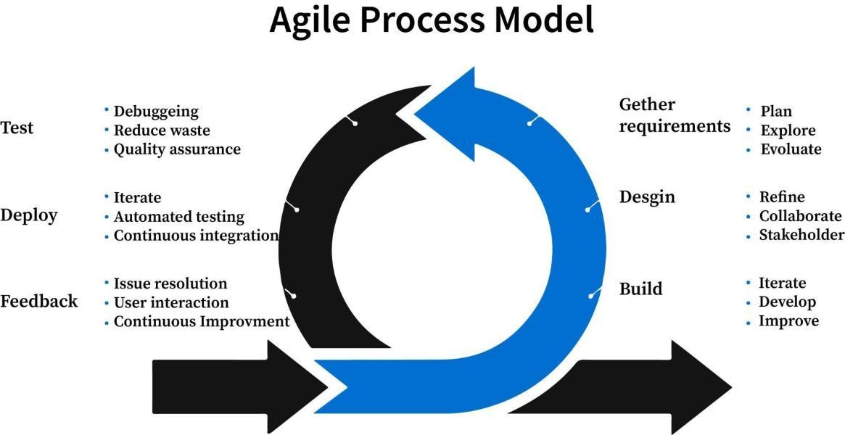

Figure 3.1 Agile Process Model

It allows us to work more efficiently on the software project in the early stages of the software life cycle. One of the key benefits of this process model is that it makes it easy to test and debug software during smaller iterations. Referred to Figure 3.1 above, Additionally, customers are involved in each build, which helps us to ensure that we meet their needs and expectations.

Another advantage of the Agile model is that it has low delivery costs, making it a more cost-effective approach to software development. It also provides a framework for managing risks and adapting to changes in the project scope. With this process model, we can easily manage the risks associated with software development and make changes as needed to meet our goals.

Our primary aim in selecting the Agile process model is to update the software into more versions. With the Agile model, we can allow patients and hospital staff to book appointments, manage schedules and make transactions for appointments with using this mobile application.

It involves the requirements gathering, design, implementation, testing and evaluation of a solution that allows patients and hospital staff to book appointments, manage schedules and make transactions for appointments with using this mobile application.

### 3.1.2 Design Phase

In the Design Phase we focused on identifying the needs of patients and doctors to design a mobile application that makes the appointment-booking process simple and efficient. We studied existing appointment and healthcare apps to understand how they manage user registration, doctor listings, schedules, and appointment confirmation. This helped us highlight the areas where our project can provide a smoother user experience. We also defined the key features for the application, such as patient signup/login, doctor profiles, specialization-based search, available time slots and appointment booking. We also designed the user interface to be clean, simple and accessible for all users, ensuring that navigation remains simple even for beginners. Finally, we selected Flutter for mobile app development due to its fast performance and cross-platform capabilities, and Java Spring Boot for backend services to ensure a secure and reliable connection between users and hospital data.

### 3.1.3 Implementation phase

In the Implementation Phase of our project, we developed the backend, database and mobile application according to the system design. The backend services and REST APIs were implemented using Java Spring Boot to manage user authentication, doctor schedules and appointment data. For secure and structured data storage, we designed and implemented the database in MySQL. On the front-end side, the user interface was first designed in Figma and then fully developed in Flutter, ensuring that the final mobile application matched the design closely. The Flutter application was integrated with the Spring Boot APIs to enable smooth data flow between the app and the database. Throughout the implementation, we focused on creating a responsive, user-friendly and reliable application that simplifies online hospital appointment booking.

### 3.1.4 Testing phase

In the testing phase the verified and validated of the system to ensure that it meets the desired quality standards. We also conduct unit testing using the spring-boot starter test, integration testing, performance, and security testing. Afterward, we conducted user acceptance testing to ensure that the application meets the needs of the users.

## **3.2 System Architecture**

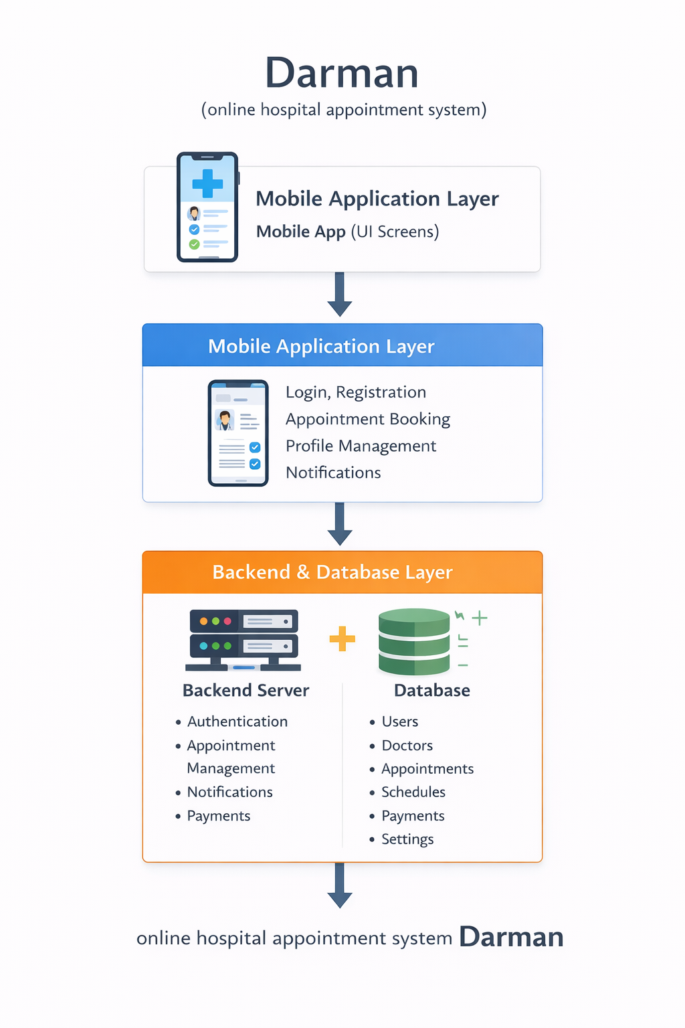

## 3.**3 Hardware and Software Requirement**

### 3.3.1 Hardware Requirement

|  |  |  |
| --- | --- | --- |
| Device Type | Laptop / Computer | Phone |
| Model | Lenovo V14 | Real me C61 |
| Processor | Intel Core i5-1235U | Octa-core |
| RAM | 8 GB | 6 GB |
| Storage | 256 GB SSD | 128GB |
| Operating System | Windows 11 | Android 15 |
| Network Connectivity | Stable internet | Stable internet |

The project requires a laptop for coding, backend testing, and database management, and a smartphone for testing the mobile application. Stable internet is needed for API connectivity and real time features.

### 3.3.2 Software Requirements

|  |  |  |  |
| --- | --- | --- | --- |
| Software component | Tools/ technology | Version | Purpose |
| Text Editor / IDE | Visual Studio Code | latest | For codding and project management |
|  | Android studio | Latest | Mobile app development and testing |
| Framework | Flutter | Latest | Mobile app development |
| Programming language | Dart | Latest used with flutter | Mobile app development |
| Backend | Supabase | Latest | Storing user, appointment and payment data |
| Other Tools/ libraries | Flutter packages /plugins | Latest | For notification. Payments , UI components |

The **Darm $\acute{a}$ n** system is developed using flutter for mobile application development (with dart). Supabase is used as backend services for authentication, API handling. Development is done using Visual Studio and Android Studio, with additional Flutter packages for notification, and Payments**.**

## 3.4 Use Case diagram

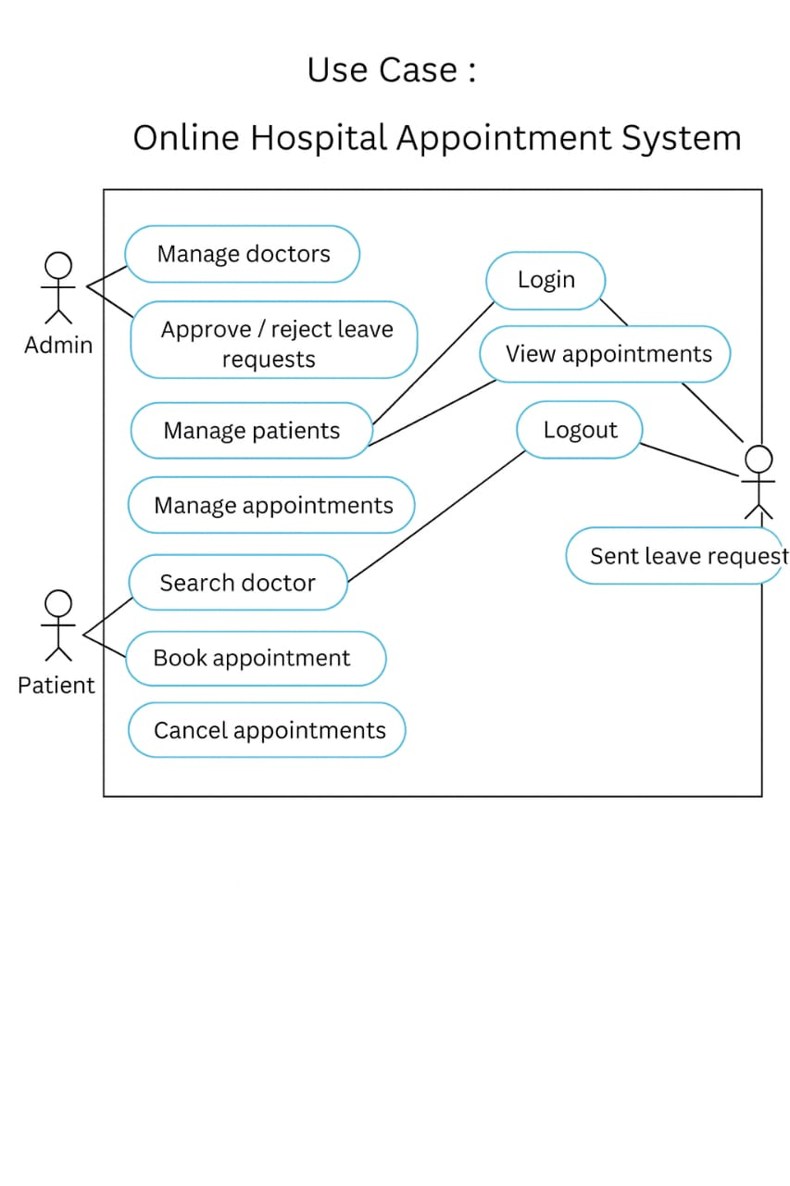

|  |  |  |
| --- | --- | --- |
| Actor | Use case | Description |
| Admin | Login | Admin logs into the system |
| Admin | Manage doctors | Add, update or remove doctor details |
| Admin | Approve/reject leave requests | Handle doctors’ leave request |
| Admin | Manage patients | View and manage patients records |
| Admin | Manage appointments | Update or cancel appointments |
| Admin | view appointments | View all scheduled appointments |
| Admin | Logout | Exit the system securely |
| Patients | Login | Patient logs into the system |
| Patients | Search doctor | Search doctors by specialization or name |
| Patients | Book appointment | Book appointments according to the doctors specialization and time |
| Patients | View appointments | View booked appointments |
| Patients | Cancel appointments | Cancel previously booked appointments |
| Patients | Logout | Exit the system securely |
| doctor | Login | Doctor logs into the system |
| doctor | View appointments | View assigned appointments |
| doctor | Send leave request | Submit leave request to admin |
| doctor | Logout | Exit the system securely |

## 3.5 Final Interfaces

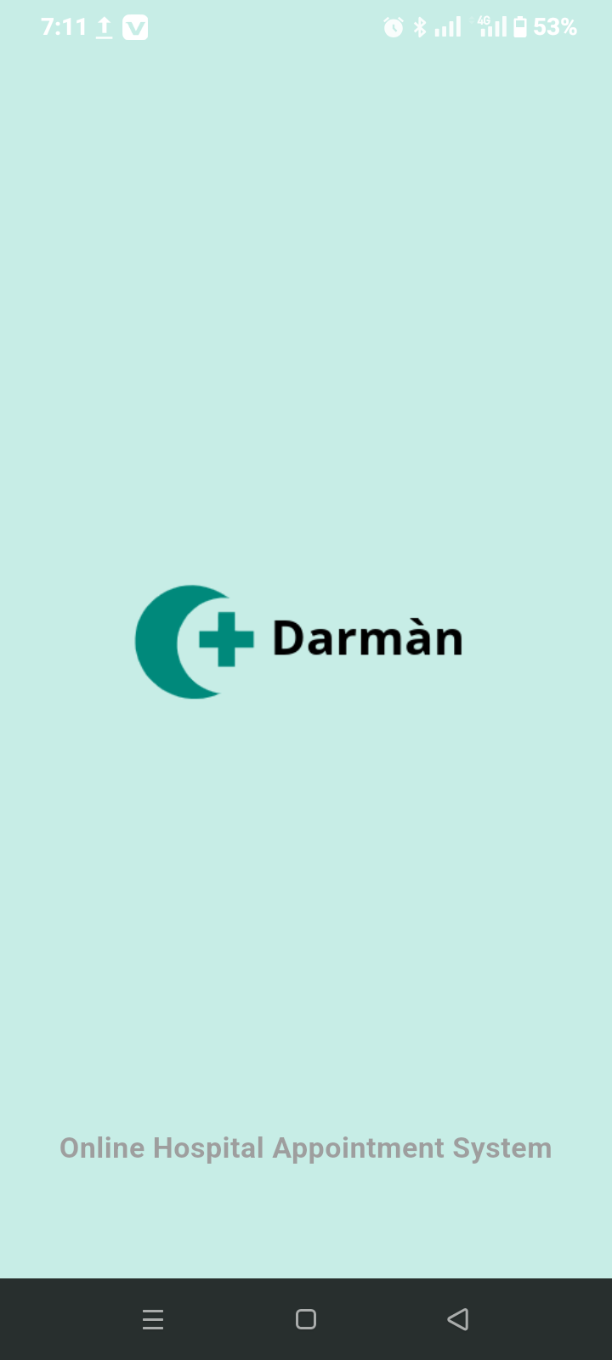  
Figure: 3.5.1

### 3.5.1 Splash Screen

Description: This screen is displayed when the Darmān application is launched. It shows the application logo and name while the system initializes and loads required resources.

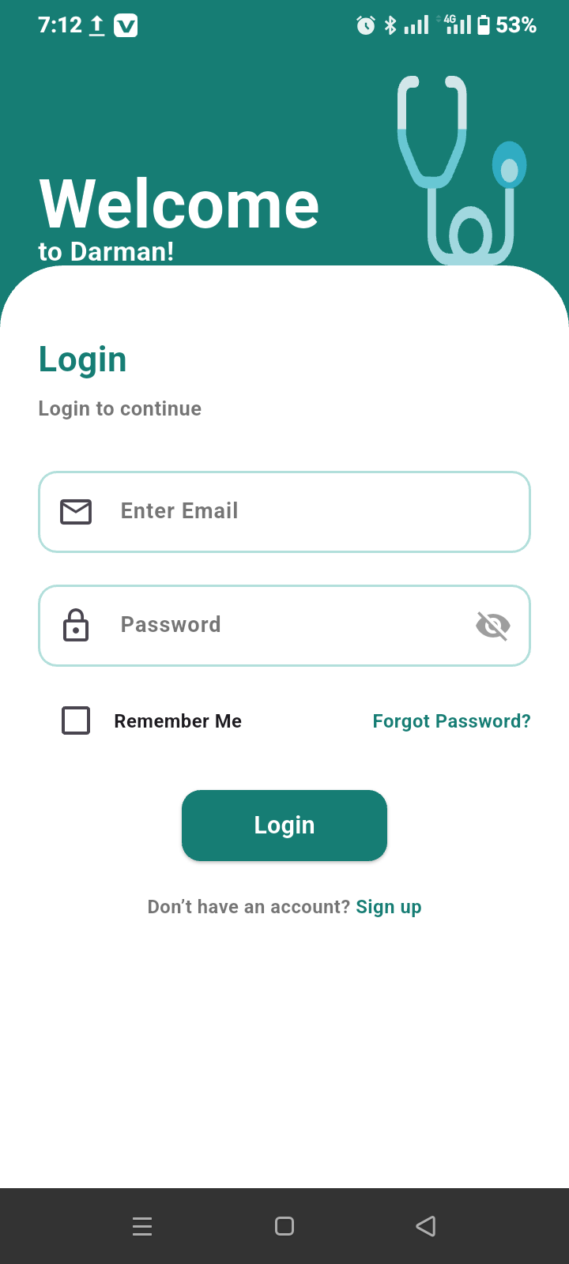

Figure: 3.5.2

### 3.5.2 login Screen

Description: This screen allows registered users to log in to the system by entering their email/username and password. It provides secure access to patient features after successful authentication.

### 3.5.3 Forgot Password Screen

Description: This screen allows users to recover their account if they forget their password. The user enters their registered email or phone number to request password recovery.

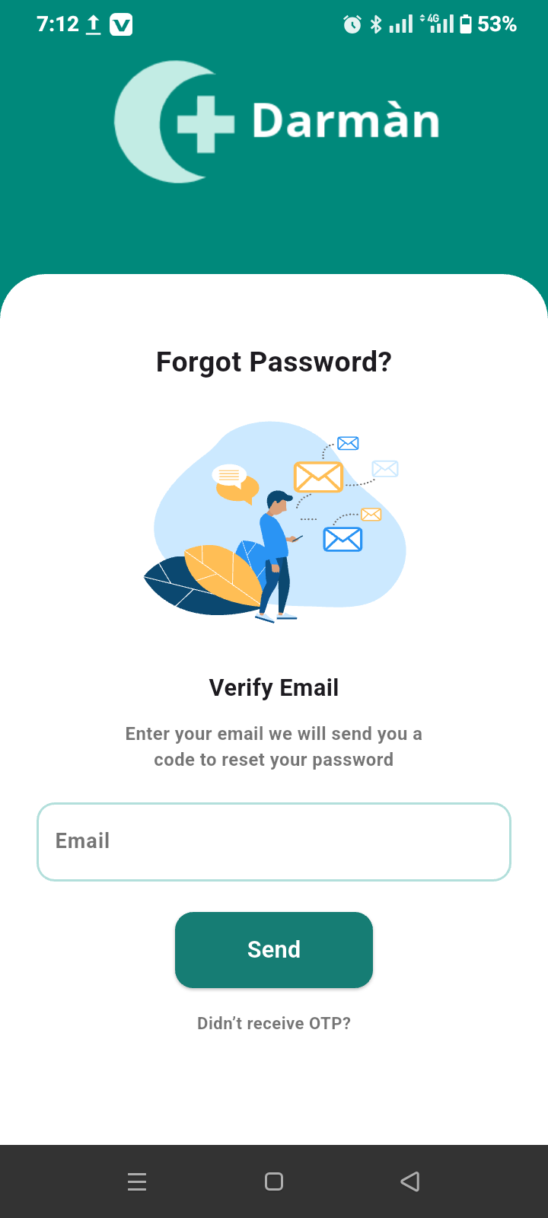

Figure: 3.5.3

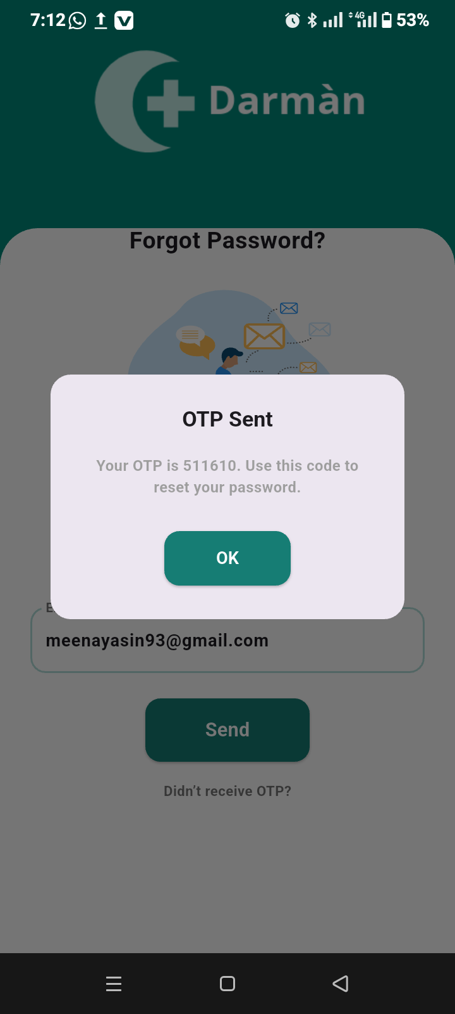

Figure: 3.5.4

### 3.5.4 OTP pop up

This pop up tells users the OTP code so that users can easily reset their passwords.

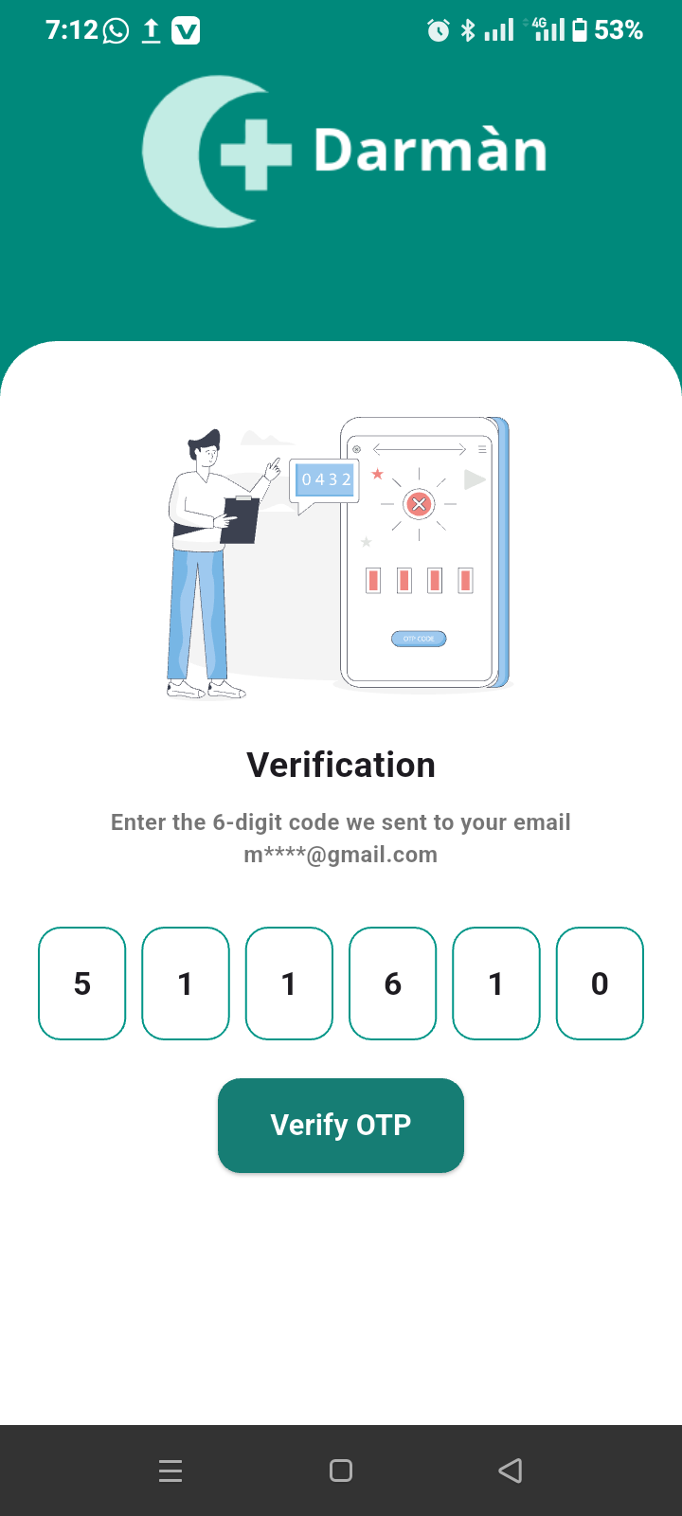

Figure: 3.5.5

### 3.5.5 OTP Verification Screen

Description: This screen is used to verify the user’s identity. An OTP (One-Time Password) is sent to the user’s registered contact, which must be entered to proceed further.

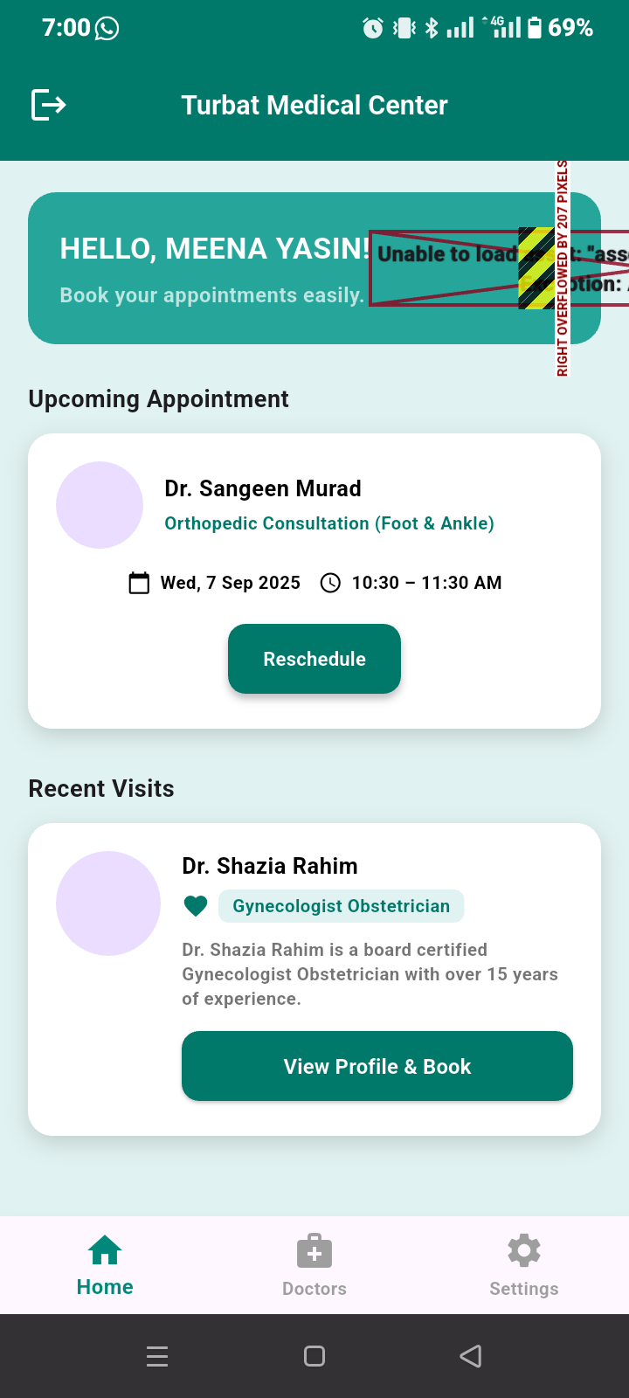

Figure: 3.5.6

### 3.5.6 Patient Screen

Description: This screen serves as the main dashboard for the patient after successful login into the Darm $\acute{a}$ n application, providing a quick overview of appointment activities and easy access to booking services. It displays a personalized welcome message with the patient’s name, shows details of the upcoming appointment including doctor name, specialization, date, andtime with an option to reschedule if needed, and also lists recent visits where previously consulted doctors are shown along with their specialization, allowing patients to view doctor profiles and book appointments again easily**.**

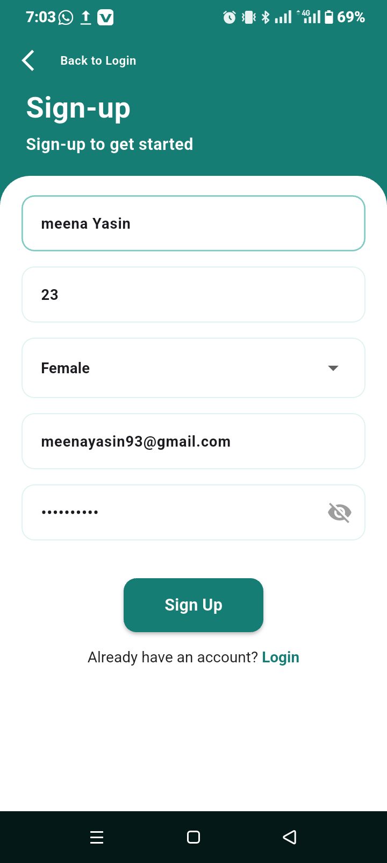

Figure: 3.5.7

### 3.5.7 Sign Up Screen

Description: This screen allows new patients to create an account by entering personal details such as name, email, phone number, and password. Successful registration enables access to the system.

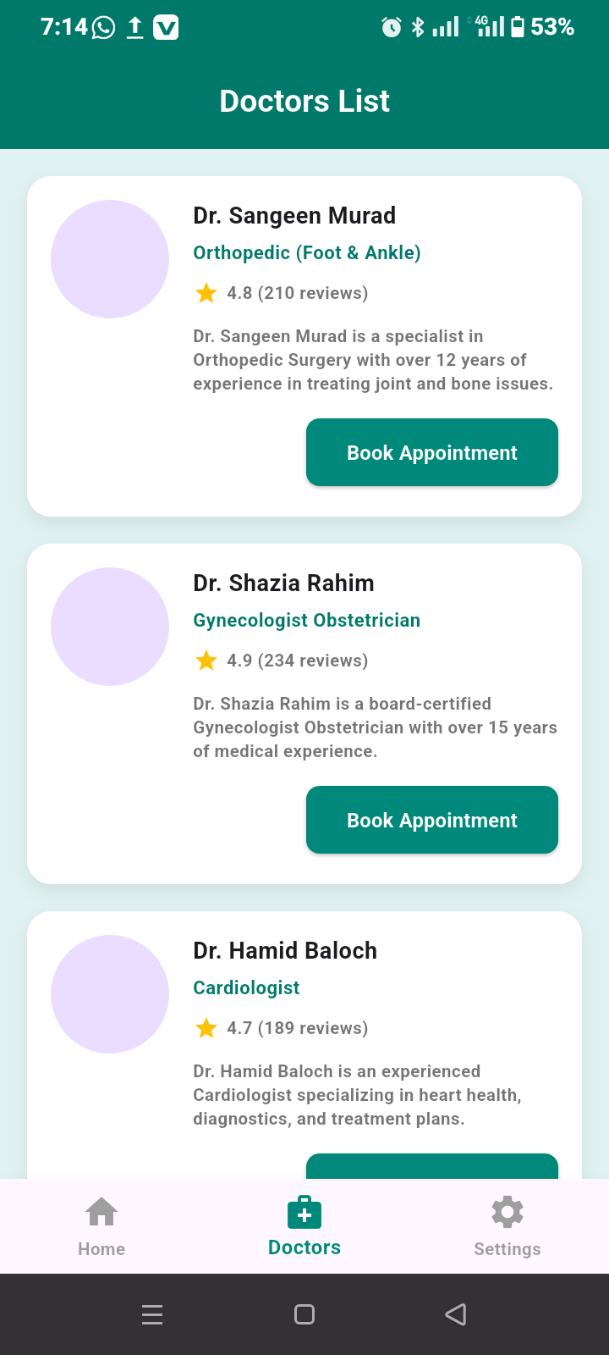

Figure: 3.5.8

### 3.5.8 Doctor List Screen

Description: This screen displays the list of available doctors in the Darm $\acute{a}$ n application, allowing patients to browse doctors easily based on their specialization. Each doctor profile includes the doctor’s name, specialty, experience summary, rating, and patient reviews to help patients make informed decisions. The screen also provides a **Book Appointment** option for each doctor, enabling patients to quickly select a doctor and proceed with appointment booking in a simple and convenient manner.

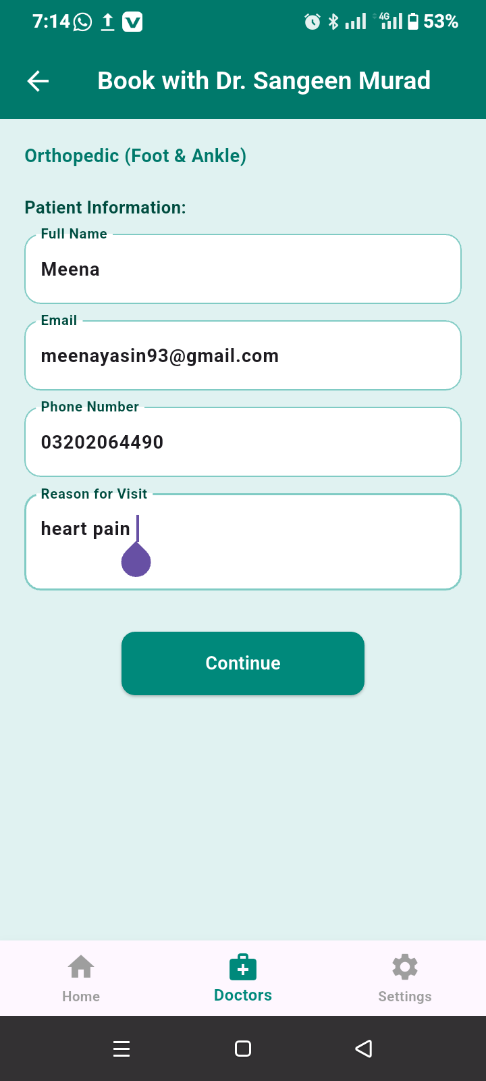

Figure: 3.5.9

### 3.5.9 Patient Information Screen (Appointment Booking)

Description: This screen is used to collect and display the patient’s basic information before confirming an appointment in the Darm $\acute{a}$ n application. It shows the selected doctor’s name and specialization at the top and allows the patient to enter or verify details such as full name, email address, phone number, and reason for visit. After filling in the required information, the patients can proceed by clicking the continue button to move to the next step of the appointment booking process.

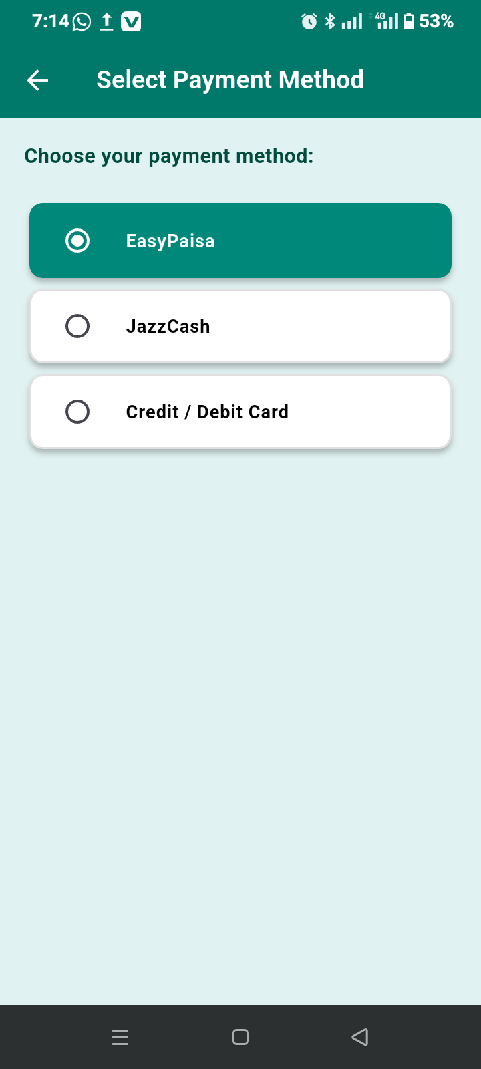

Figure: 3.5.10

### 3.5.10 Payment Method Screen

Description: This screen allows patients to select a preferred payment method and complete the consultation fee process securely before confirming the appointment.

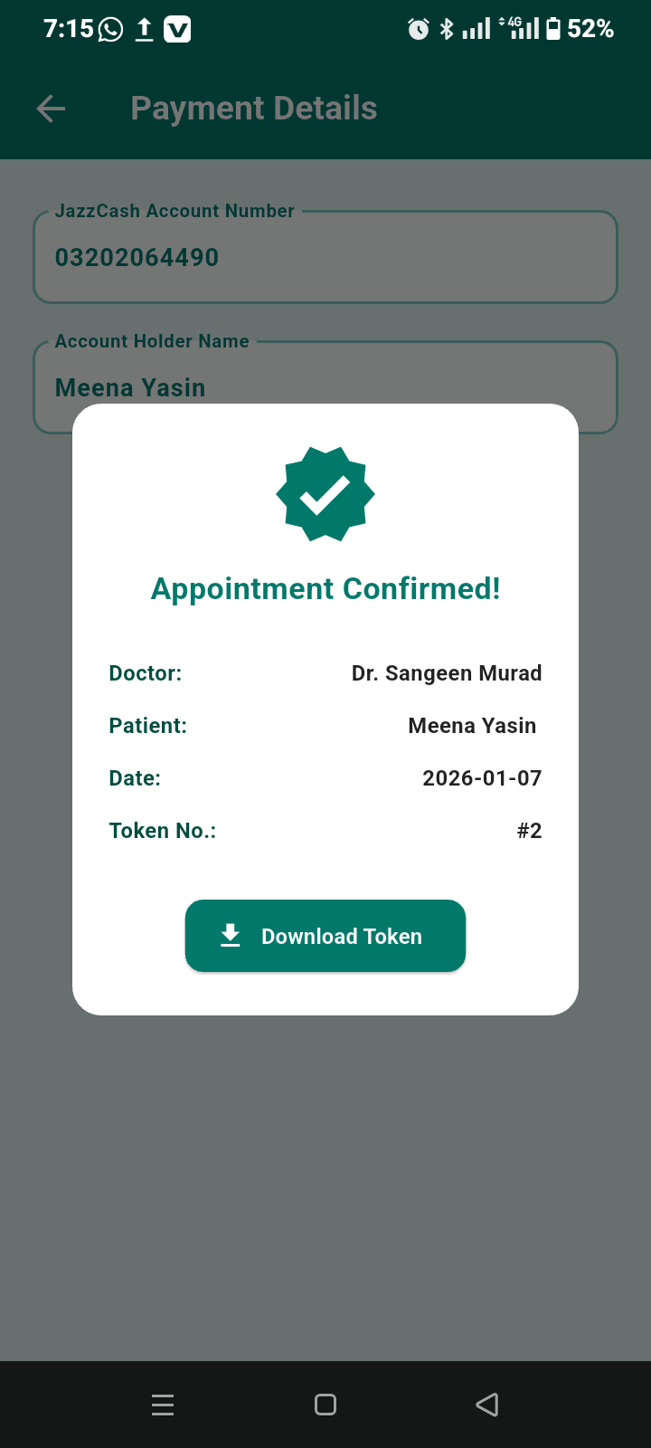

Figure: 3.5.11

### 3.5.11 Appointment Confirmed Screen

Description: This screen displays confirmation details after a successful appointment booking and payment. It shows appointment information such as doctor name, date, and time. And option for downloading the token.

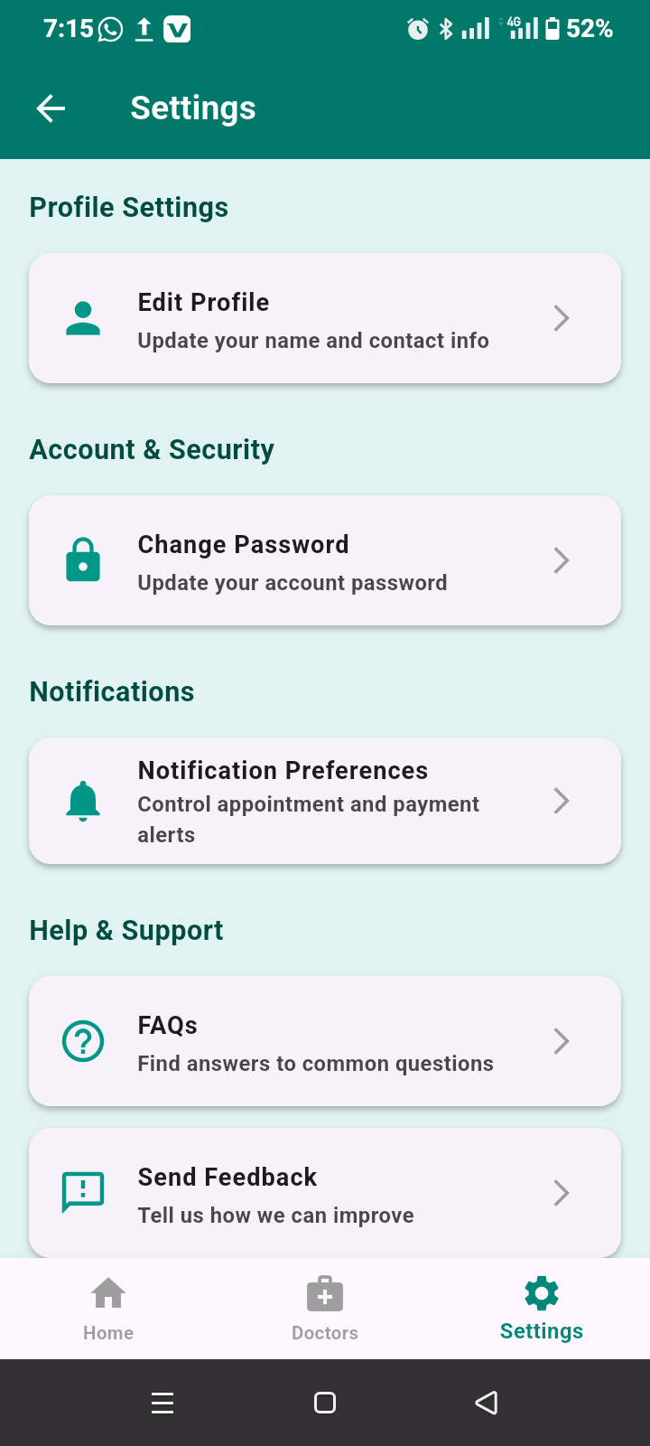

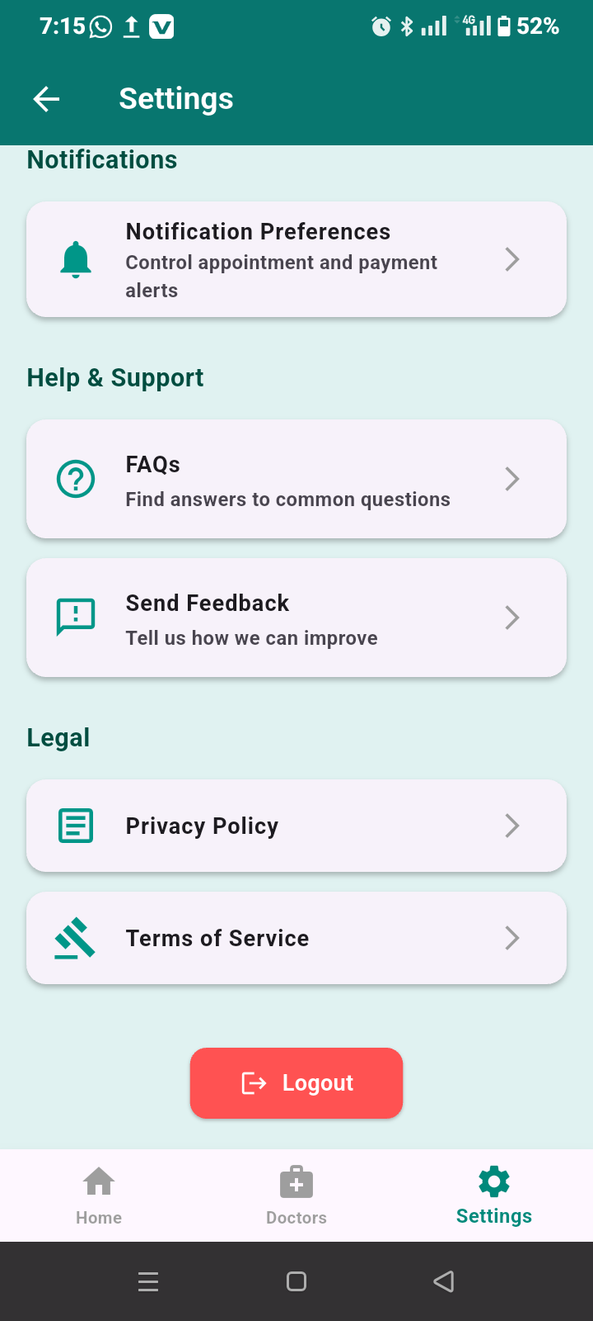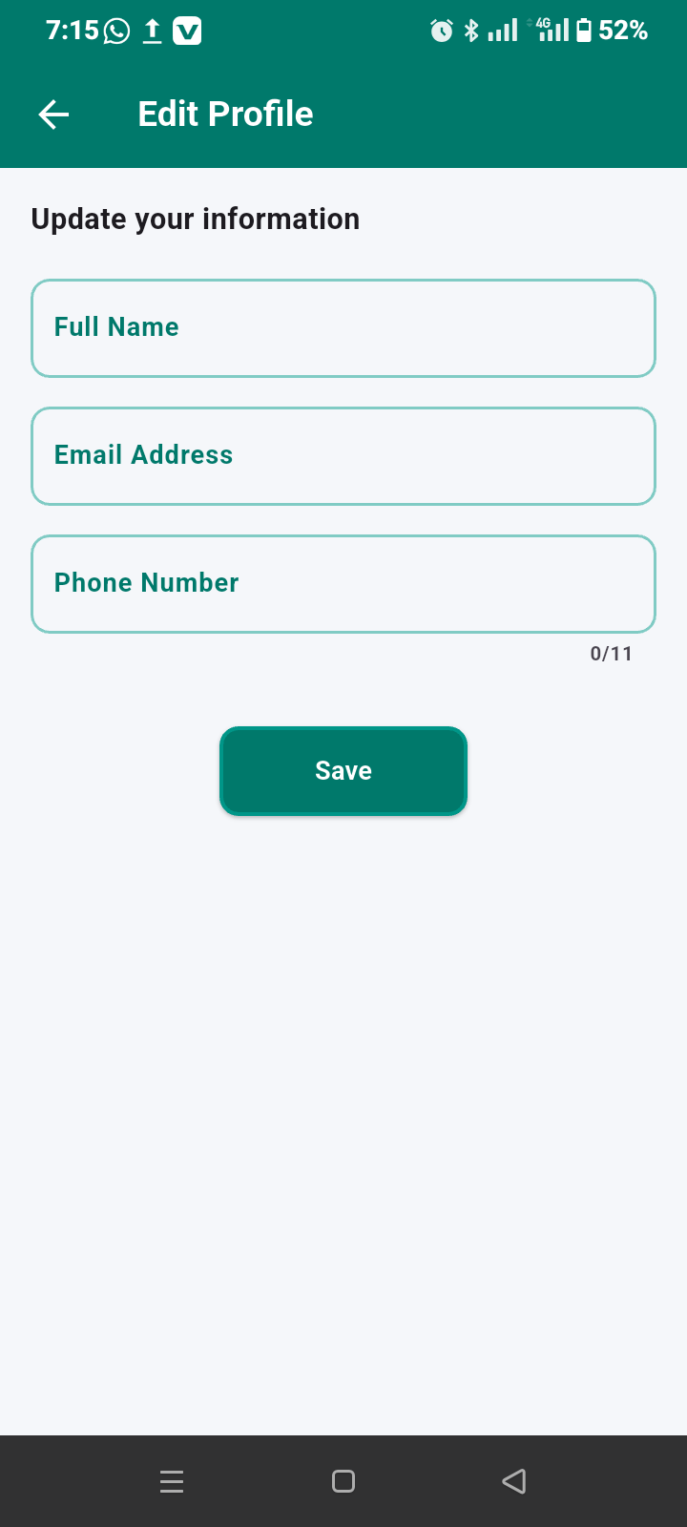

Figure: 3.5.12

### 3.5.12 Edit Profile Screen

Description: his screen allows the patient to update personal account information in the Darm $\acute{a}$ n application. It provides editable fields for full name, email address, and phone number, enabling patients to keep their profile details accurate and up to date. After making the required changes, the patient can save the updated information using the save button, ensuring that the revised details are stored securely in the system.

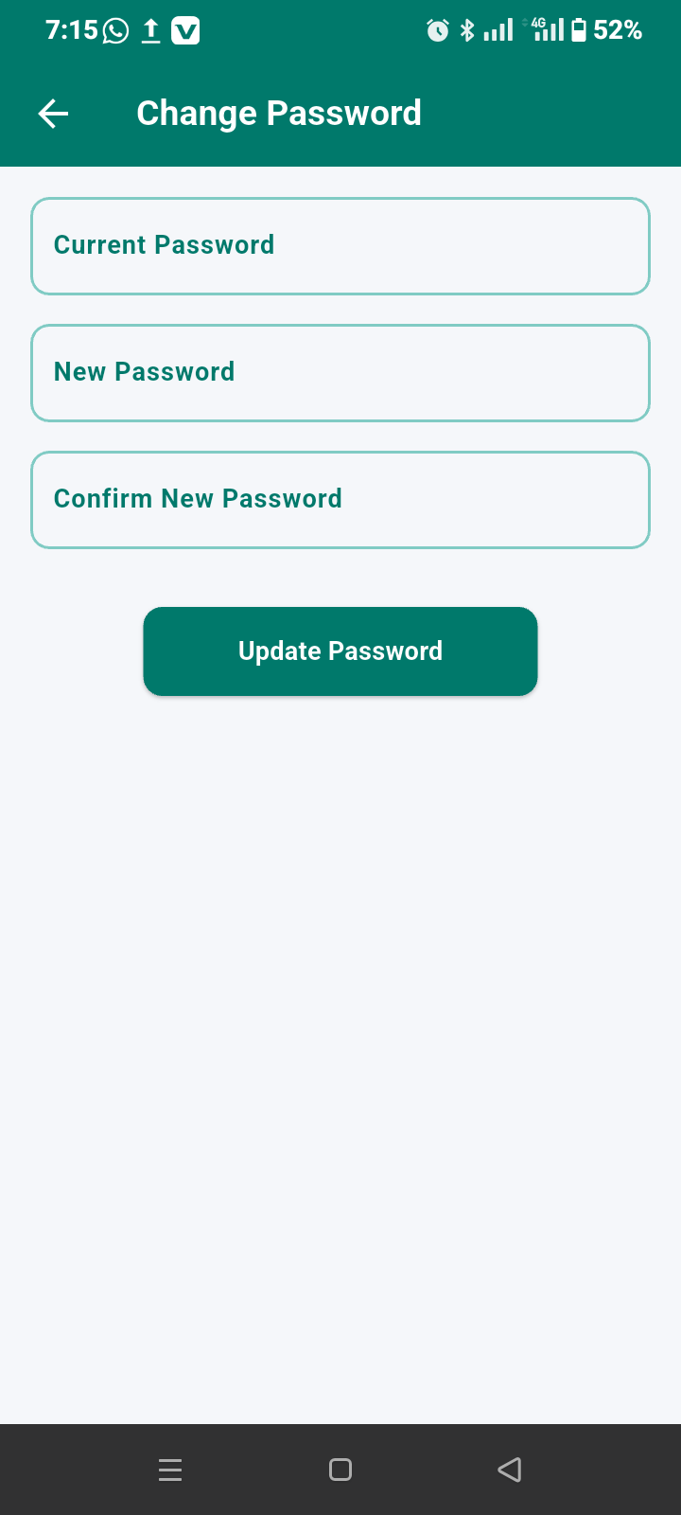

Figure: 3.5.13

### 3.5.13 Change Password Screen

Description: This screen allows patients to change their account password by entering the current password and setting a new one.

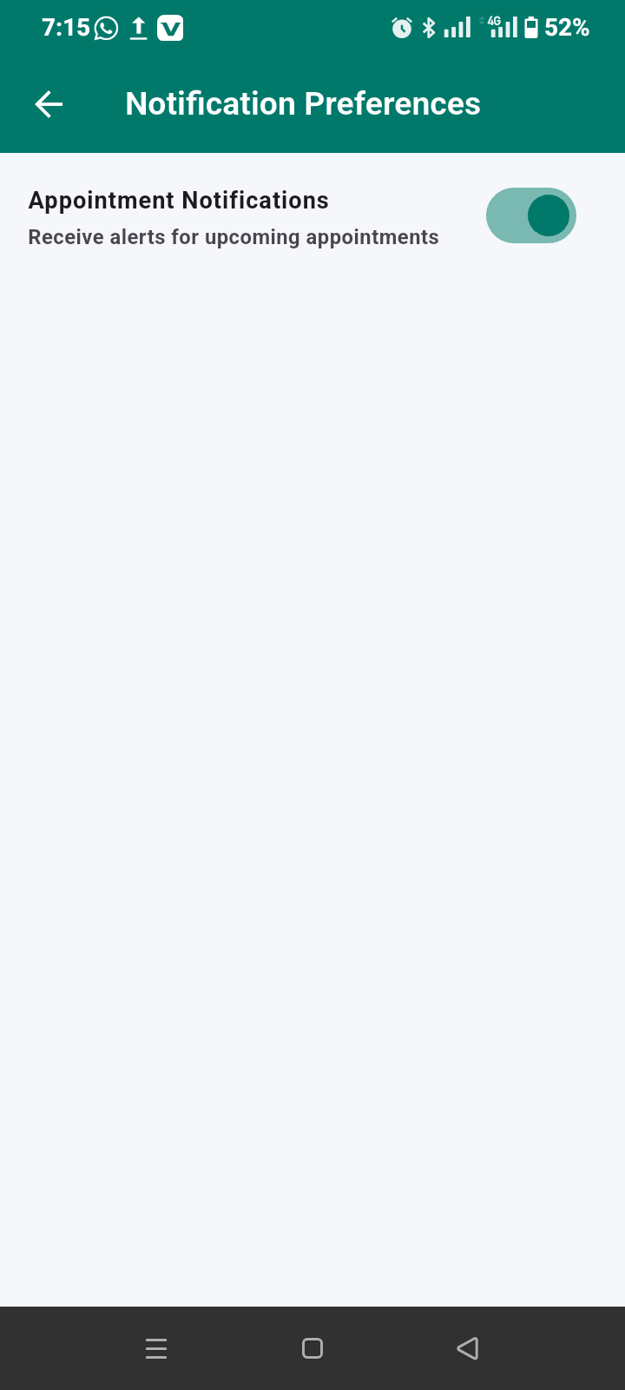

Figure: 3.5.14

### 3.5.14 Notification Screen (Patient)

Description: This screen displays notifications related to appointment confirmations, reminders, updates, and other system alerts.

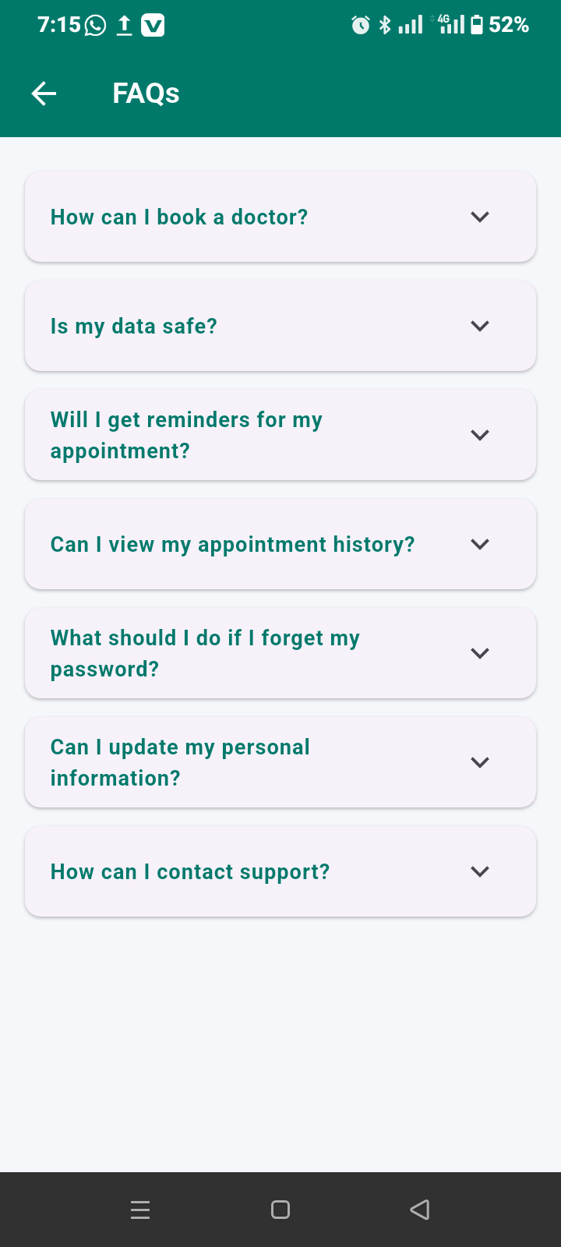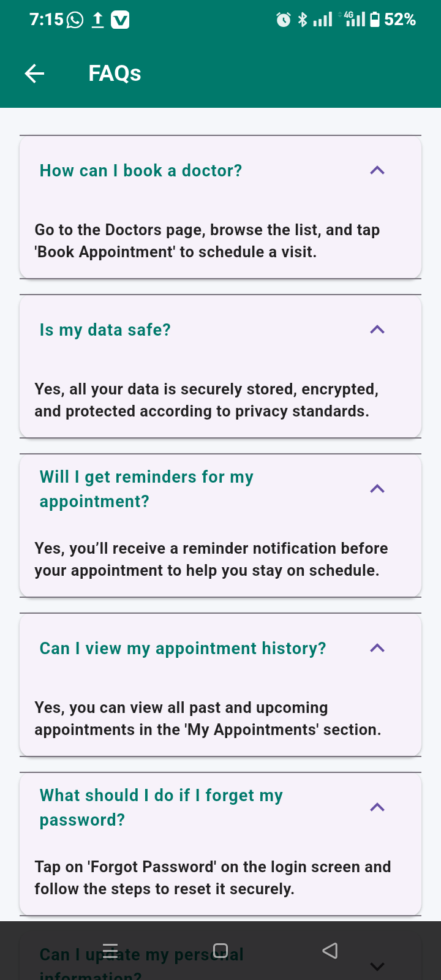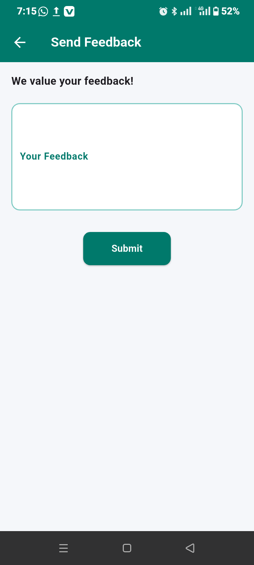

Figure: 3.5.15

### 3.5.15 Feedback Screen

Description: This screen allows patients to submit feedback, suggestions, or complaints regarding the application or hospital services.

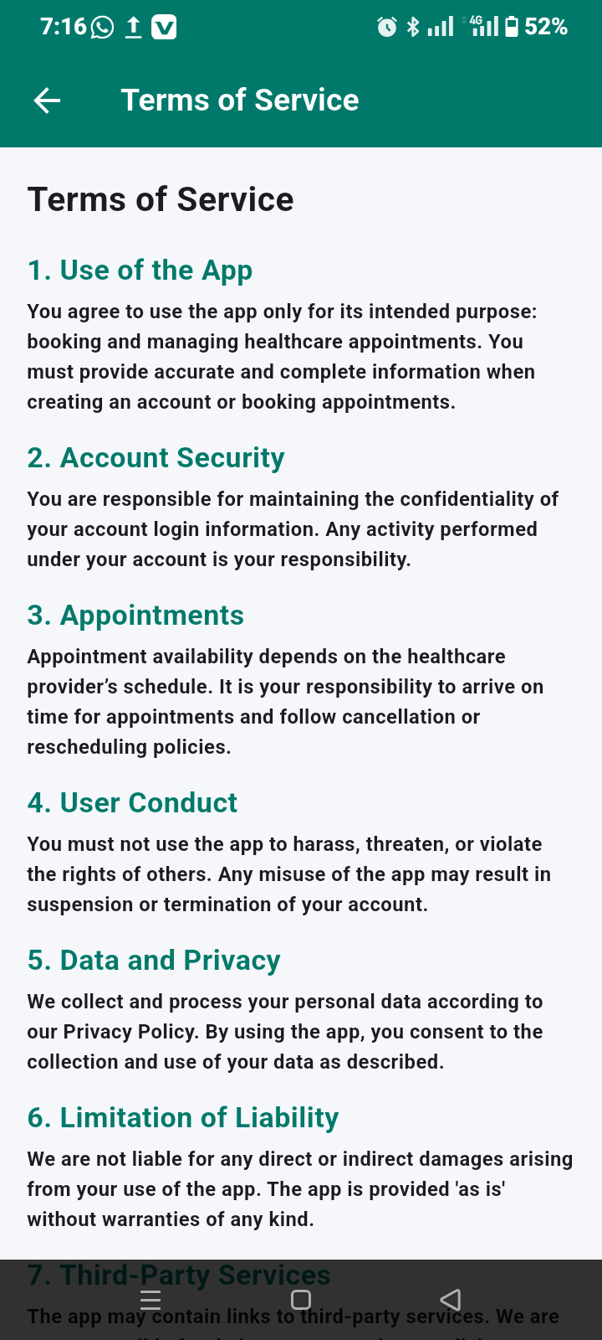

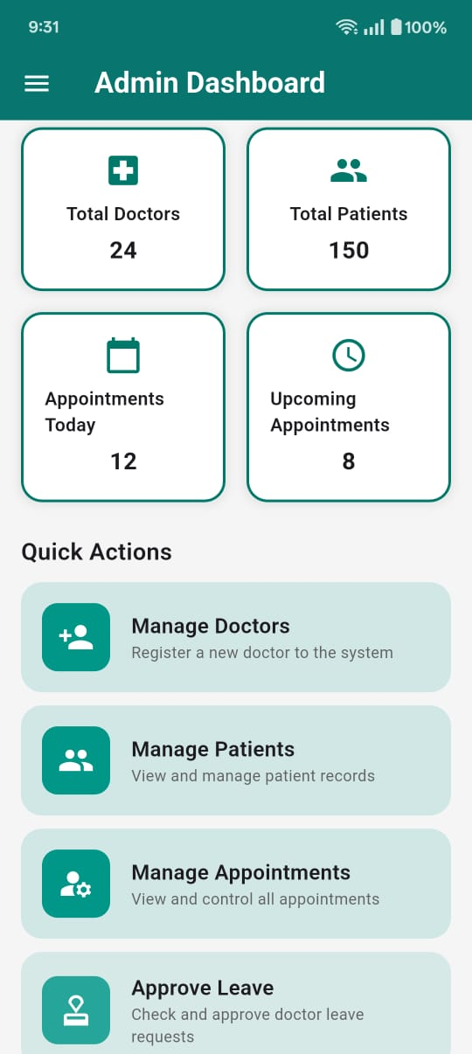

Figure: 3.5.16

### 3.5.16 Admin Dashboard Screen

Description: The Admin Dashboard of the Darm $\acute{a}$ n Hospital System serves as the central control panel for administrators, providing a quick overview of hospital activities. It displays key statistics such as the total number of doctors and patients, the number of appointments schedule for today, and upcoming appointments. The dashboard also includes quick action options that allow the admin to manage doctors by registering and updating their information, manage patient records, control and monitor appointments, and approve doctor’s leave requests. This Screen is designed to help administrators efficiently monitor hospital operations and perform essential management tasks from one place.

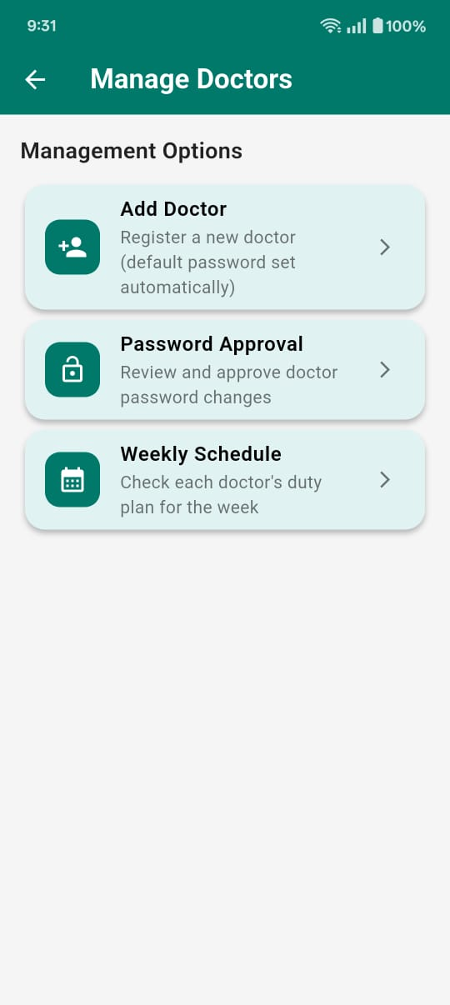

Figure: 3.5.17

### 3.5.17 Manage Doctor Screen

Description: This Screen allows the administrator to add, review and approve doctor password changes, to see weekly schedule of all doctors. It helps manage doctors schedule and availability within the system**.**

### 3.5.18 Other Admin Screens (as per screenshots)

All other Screens allow the administrator to manage patients, appointments, schedules, notifications, payment and billing, admin management, admin profile and setting and overall system operations to ensure smooth functionally of the **Darm $\acute{a}$ n** system.

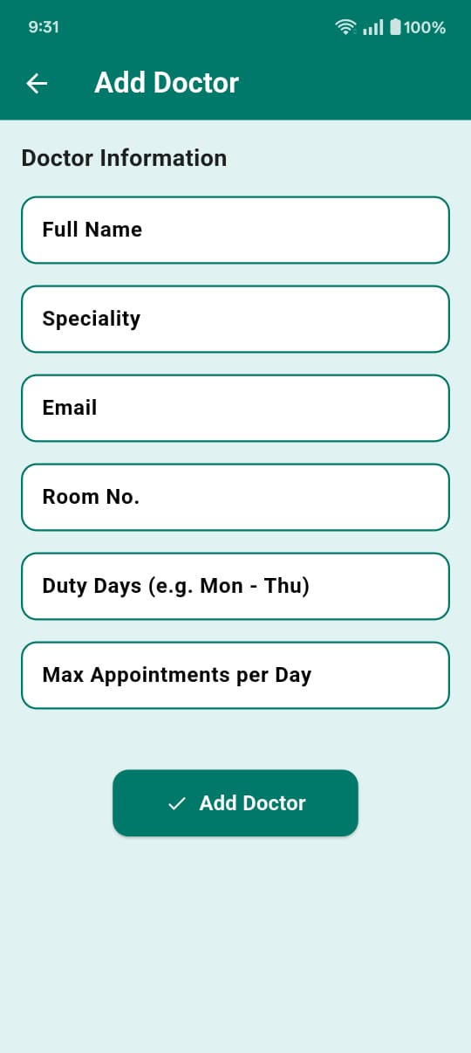

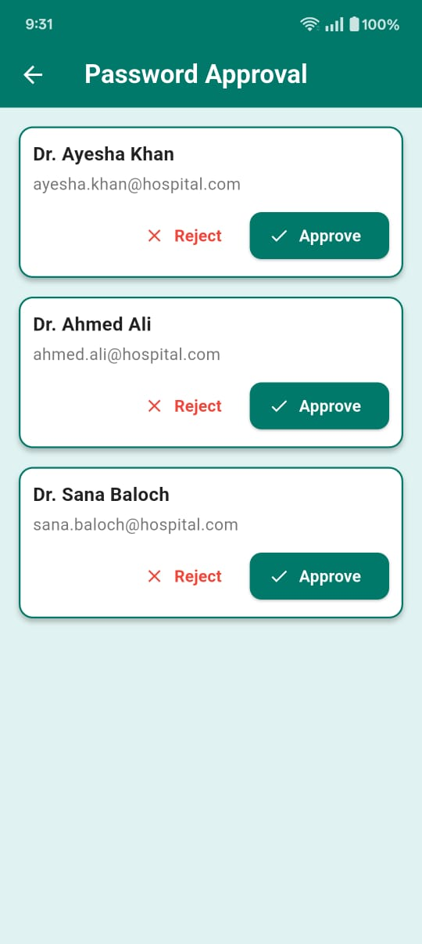

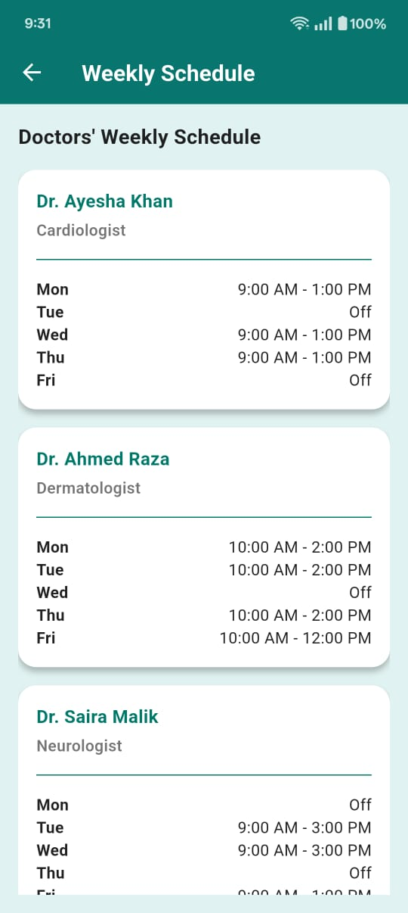

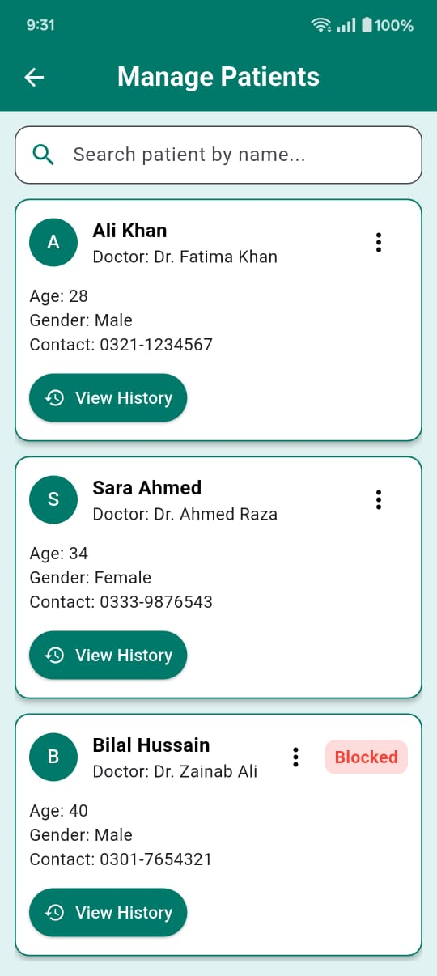

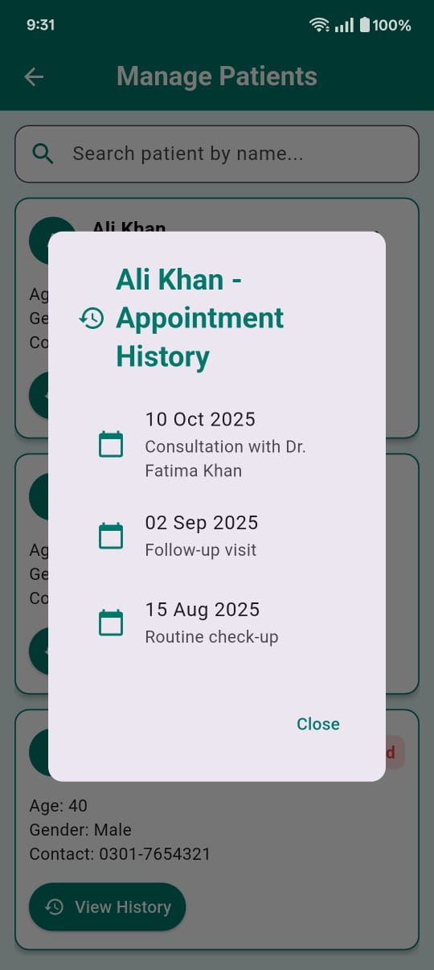

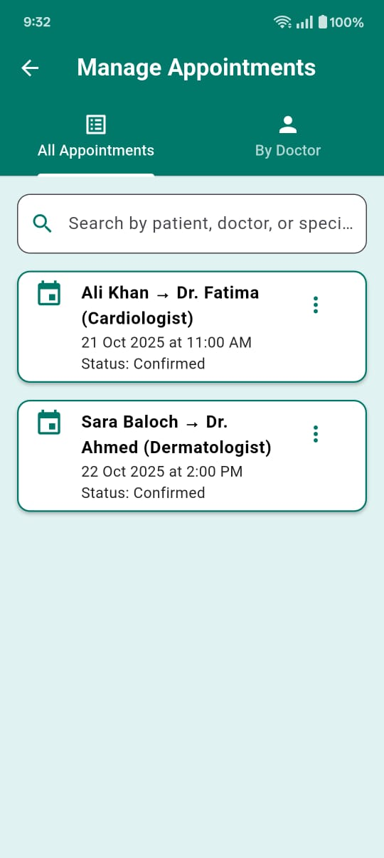

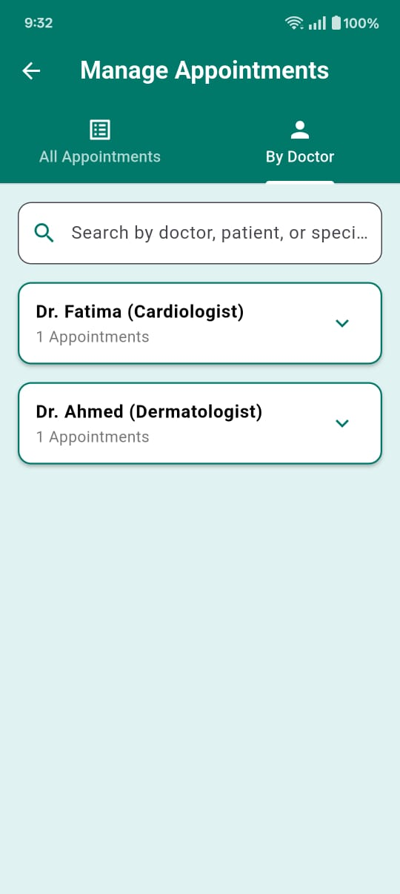

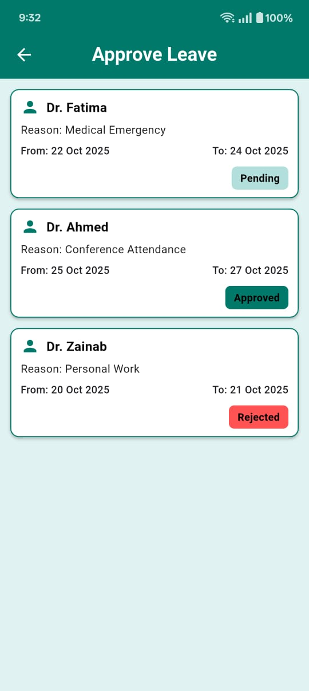

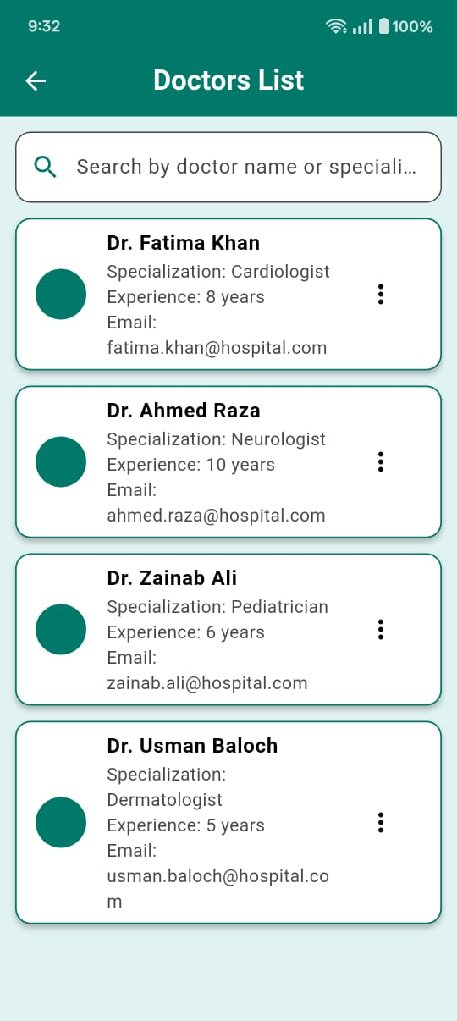

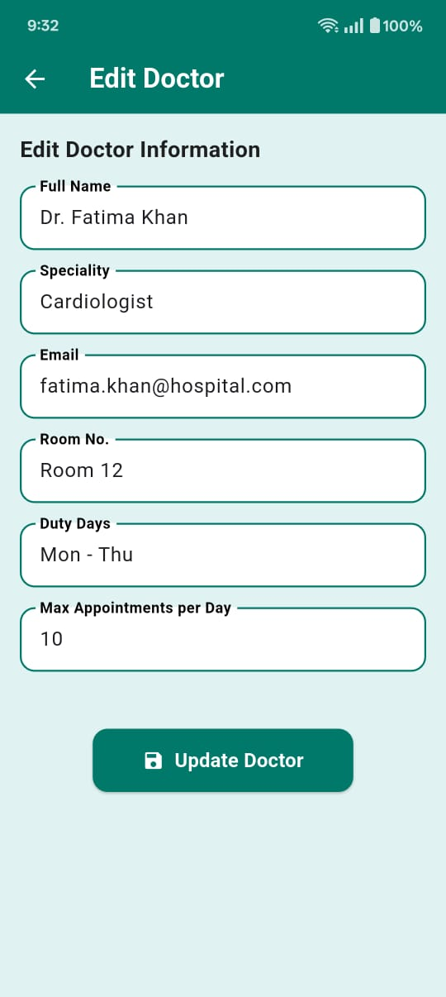

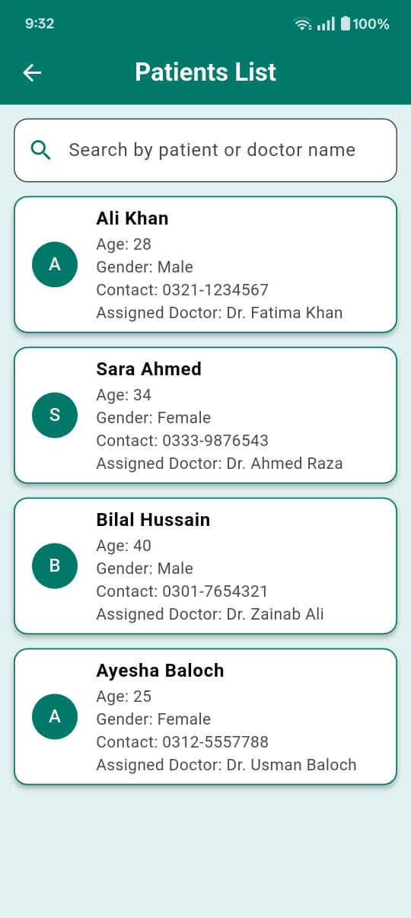

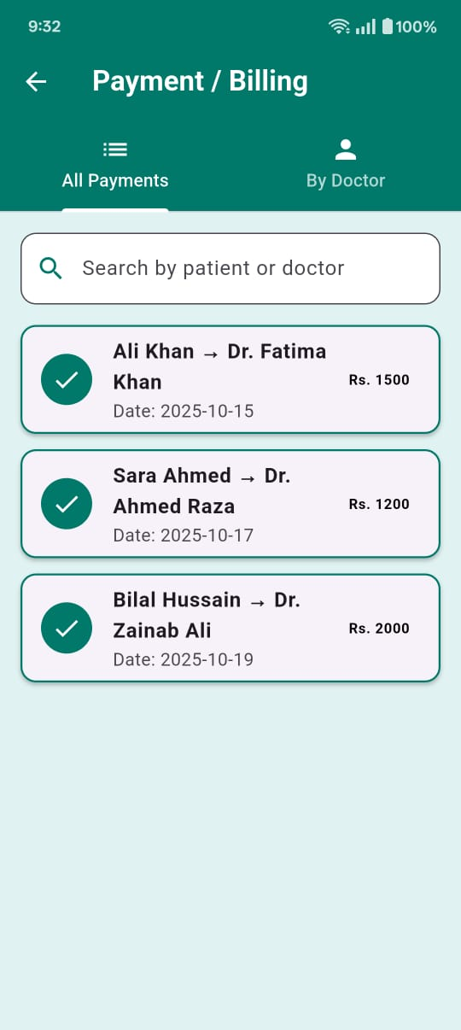

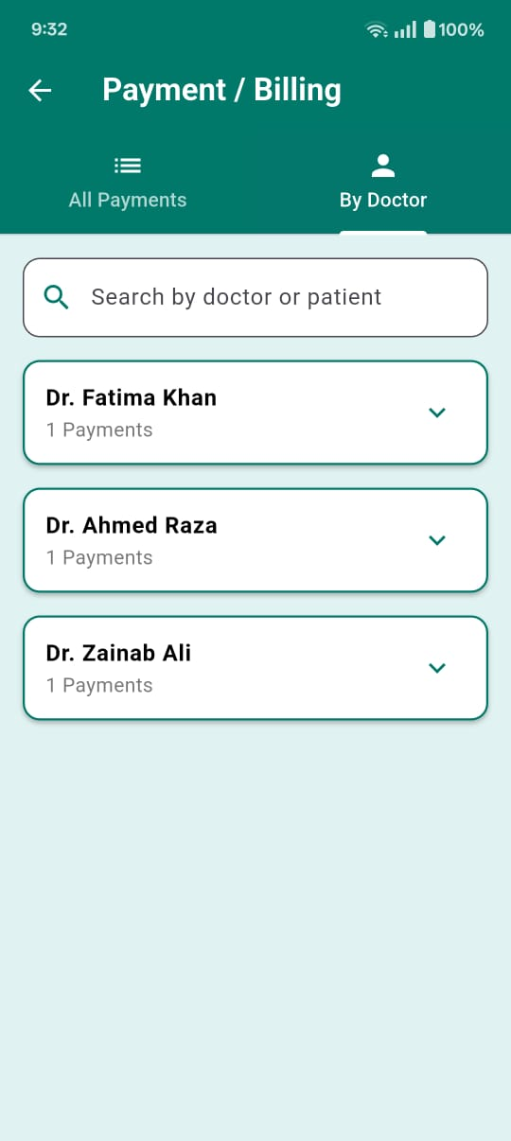

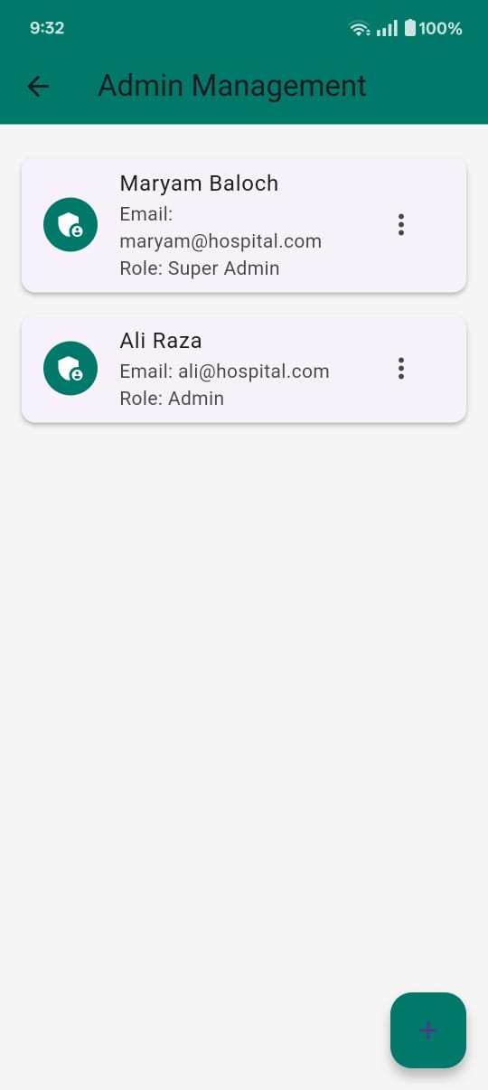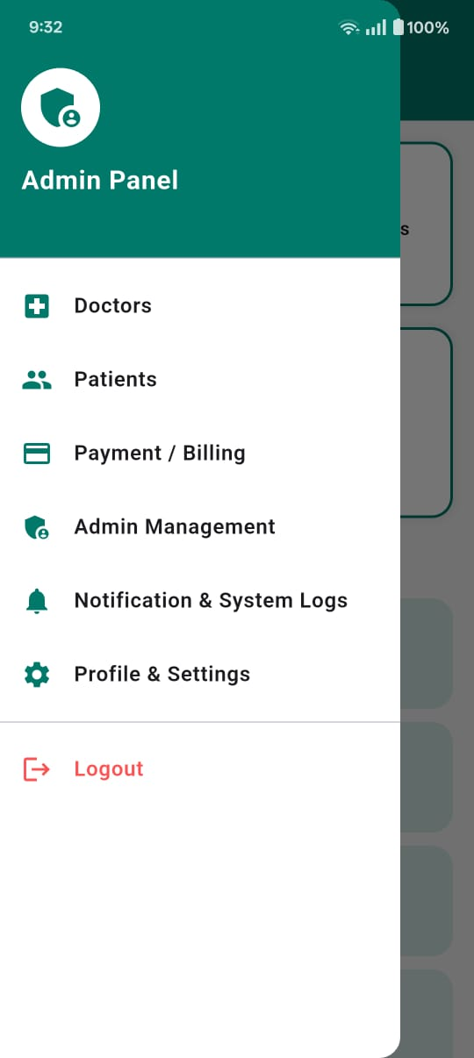

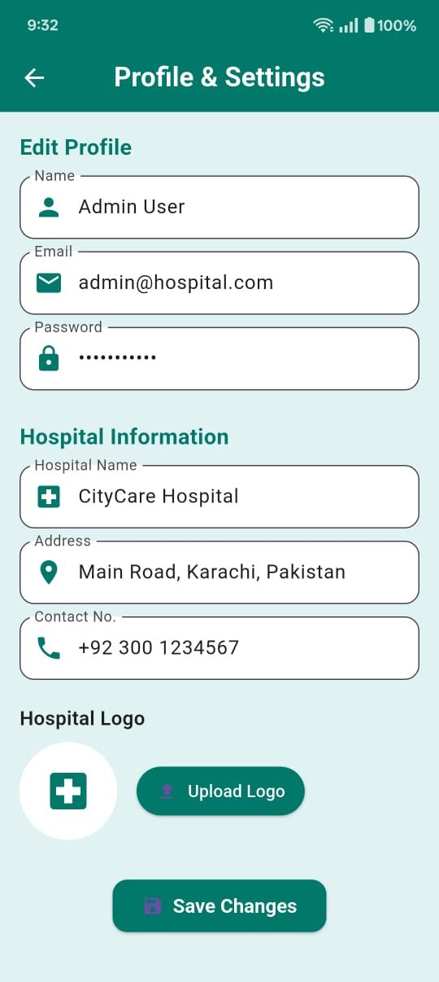

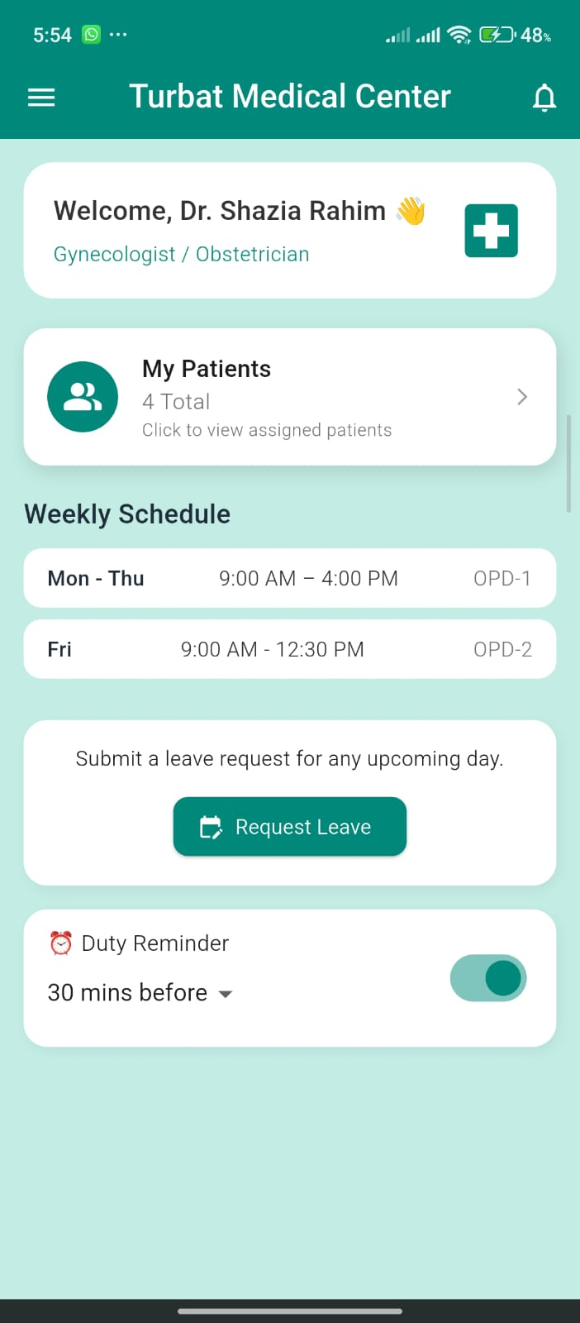

Figure: 3.5.19

### 3.5.19 Doctor Dashboard Screen

Description: This is the doctor dashboard screen serves as the main interface for doctors after successful login. It includes information like doctor’s name, designation and assigned department. This screen displays the total number of assigned patients and the weekly duty schedule with OPD timings. Additionally, it includes a leave request option and duty reminder feature.

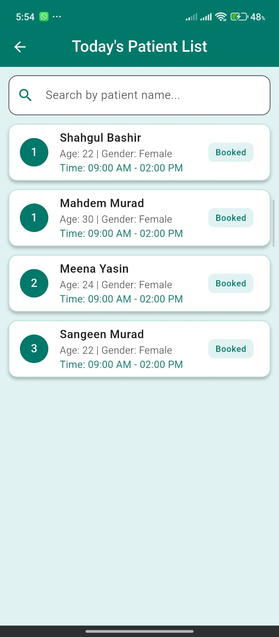

Figure: 3.5.20

### 3.5.20 Patient List Screen

Description: This screen presents a structured list of patients scheduled for consultation on the current day. It includes a search functionality that allows doctors to quickly locate patients by name with their details.

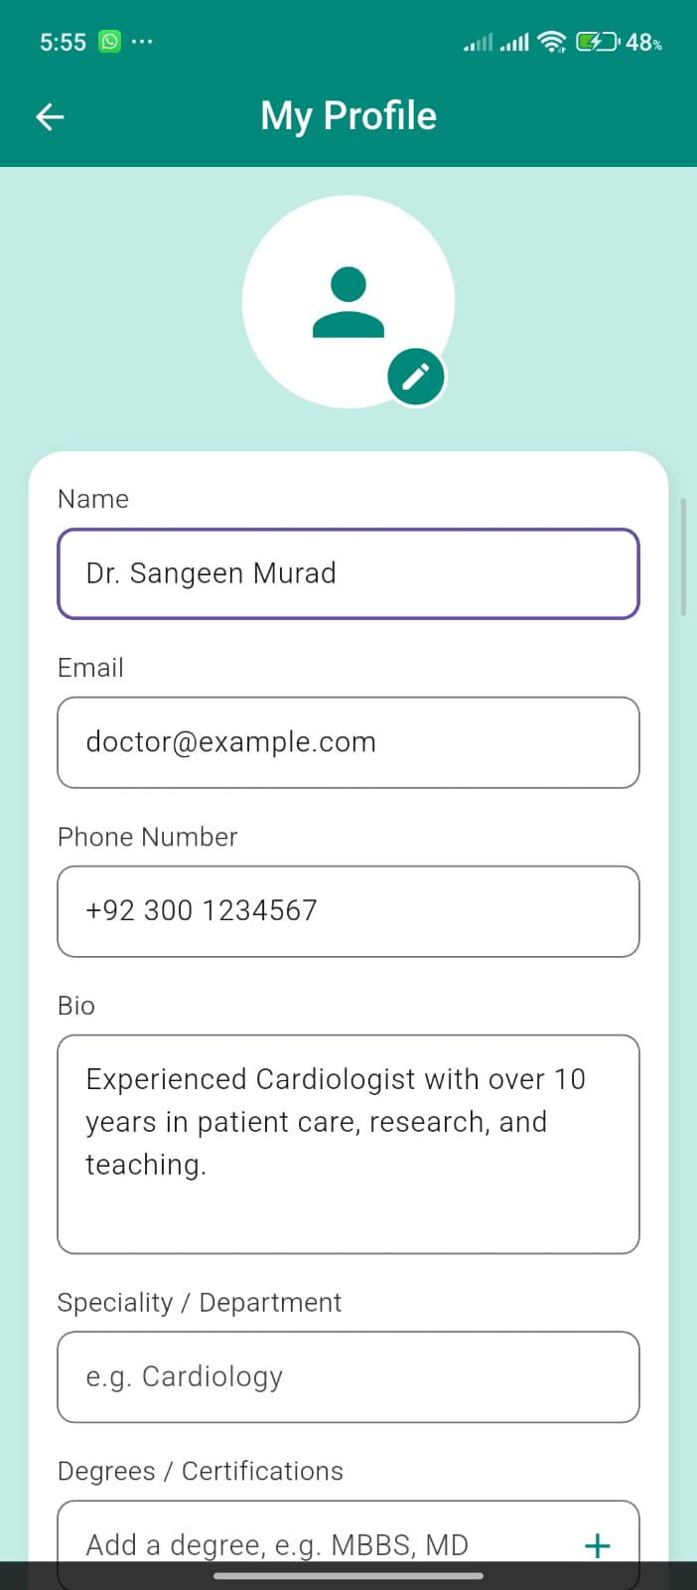

Figure: 3.5.21

### 3.5.21 Doctor Profile Screen

Description: This screen is the doctor’s profile screen where doctors can add his/her details like name, email, phone number, bio specialty and degree etc. and add a profile picture of theirs. And also doctors can edit their profile from this page.

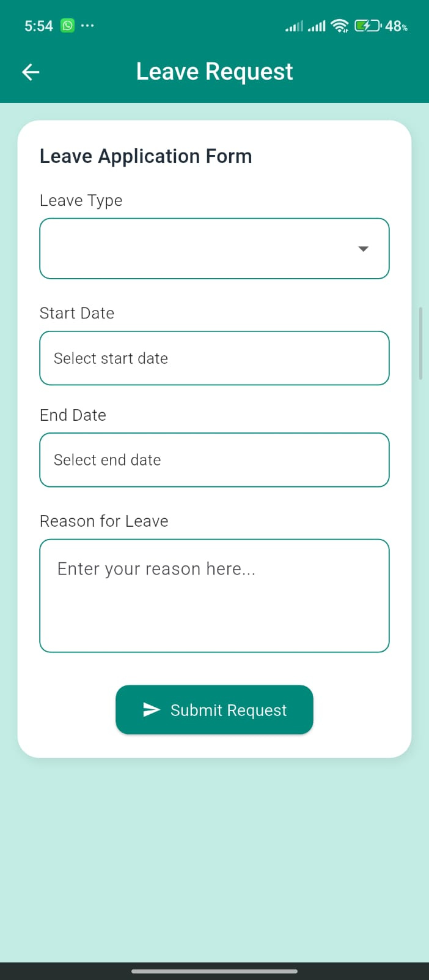

Figure: 3.5.22

### 3.5.22 Doctor Leave Request Screen

Description: This screen is used by doctors to submit a leave request in the Darmān application. It provides a leave application form where the doctor can select the leave type, choose the start and end dates of the leave, and enter the reason for requesting leave. After filling in the required information, the doctor can submit the request, which is then forwarded to the administrator for review and approval. This screen helps manage doctor availability and ensures proper scheduling of appointments within the system.

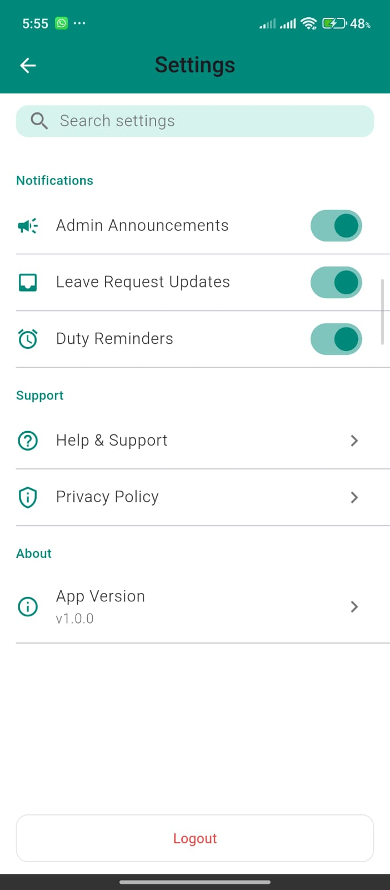

### 3.5.23 Doctor Setting Screen

Description: This screen allows doctors to manage their application settings in the Darmān system. It provides options to enable or disable notifications such as admin announcements, leave request updates, and duty reminders. The screen also includes support-related options like help and support and access to the privacy policy, along with application information such as the current app version. Additionally, the logout option is available to allow doctors to securely exit the system, ensuring account security and proper session management.

# CHAPTER 4: IMPLEMENTATION

## 4.1 Overview

This system is a modern and efficient digital platform that is developed to transform the traditional appointment booking process in hospitals. This system provides a convenient, secure, and user-friendly solution that allows patients to book medical appointments using their mobile devices, reducing the time of people.

By implementing this App, patients can easily view doctor availability and book appointments from anywhere and at any time. This reduces waiting time and improves accessibility to healthcare services. The system also supports appointment fee management, enabling patients to complete booking procedures smoothly and transparently.

Moreover, this system helps hospitals improve operational efficiency by reducing administrative workload, minimizing scheduling errors and maintaining organized digital records of appointments. Doctors and hospital staff can manage their schedules more effectively, resulting in better time management and improved patient care.

Overall, the Darm $\acute{a}$ n Online Hospital Appointment System modernizes hospital appointment management by aligning it with current technological standards. It enhances the healthcare experience for patients while providing hospitals with a reliable and efficient platform to manage appointments, making the healthcare process more streamlined and effective for all stakeholders.

### 4.1.1 Key Features

* Efficient Appointment Scheduling: Darm $\acute{a}$ n allows patients to book hospital appointments online without visiting the hospital physically. Patients can select doctors, view available doctors and book appointments easily from their phones, it helps reduce waiting times and overcrowding in hospitals.
* Secure and Reliable System: The system ensures the safety and privacy of patient data through secure authentication and data handling mechanisms. User information and appointment records are protected from unauthorized access, making the system trustworthy and reliable.
* Appointment Fee Management: Darm $\acute{a}$ n includes a method for managing appointment fees during the booking process. Patients can confirm their appointments after completing the required fee process, ensuring transparency and reducing manual handling at hospital counters.
* Doctor Schedule Management: Doctors and hospital staff can manage their schedules efficiently through the system. They can view daily appointments, update availability and avoid overlapping or double bookings which improves overall workflow.
* User-Friendly Interface: The application is designed with a simple and easy interface which makes the system easy for patients, doctors, and staff to use. Clear navigation and structured screens help user’s complete tasks quickly without technical difficulty.
* Reduced Administrative Workload: By making the appointment process digital, this system reduces the administrative burden on hospital staff. Manual record keeping is minimized and appointment data is stored digitally for easy access and management.

## 4.2 System Overview

**Darm $\acute{a}$ n** is providing a high-level key component for its users which are the following:

### ****4.2.1 User Interface****

The user interface of Darm $\acute{a}$ n is a mobile-based application designed to work smoothly on Android devices and iOS both. It provides a simple, clean and user-friendly layout that allows patients, doctors and hospital staff to easily register, login, book appointments and manage schedules without technical difficulty.

### ****4.2.2 Authentication and Security****

Darm $\acute{a}$ n implements secure authentication mechanisms using username and password to protect user accounts. The system ensures data confidentiality by securing patient information, appointment records and doctor schedules.

### ****4.2.3 Appointment Processing****

The system allows patients to book appointments with doctors in real time. Patients can select a department, choose a doctor, view available doctors5 and confirm their appointments. The system prevents duplicate bookings and ensures smooth appointment management.

### ****4.2.4 Appointment Fee Management****

**Darm $\acute{a}$ n** includes a mechanism for managing appointment fees. Patients are required to complete the appointment fee process before confirming their booking. This helps reduce manual fee collection and ensures transparency in hospital operations.

### ****4.2.5 Schedule Management****

Doctors and hospital staff can view and manage daily appointment schedules through the system. They can update availability, approve appointments, and monitor patient visits, which improves workflow and time management within the hospital.

### ****4.2.6 Notification System****

The system provides notifications to users regarding appointment confirmations, schedule updates, and cancellations. These alerts help patients remember their appointments and keep

doctors informed about their daily schedules.

## 4.3 Technologies and Tools Used

|  |  |  |
| --- | --- | --- |
| Tools/technologies | versions | motive |
| Flutter | 3.x | Framework |
| Dart | 3.x | Programming language |
| Supabase | latest | Database |
| Figma | latest | Design |
| Android studio | latest | IDE |

# CHAPTER NO 5: CONCLUSION

Lastly, **Darm $\acute{a}$ n (Online Hospital Appointment System)** is a modern digital solution designed to improve the traditional hospital appointment process. Initially, the system is intended to be used within a hospital environment but in the future, it can be expanded to multiple hospitals and healthcare centers across cities or even nationwide Darm $\acute{a}$ n represents the growing role of digital technology in healthcare by making appointment booking easier, faster and more efficient for patients and healthcare providers.

As healthcare systems continue to adopt digital solutions, platforms like Darm $\acute{a}$ n play an important role in improving service quality and patient satisfaction. Unlike traditional appointment methods that require physical visits and long waiting times Darm $\acute{a}$ n offers a user-friendly and reliable system that allows patients to book appointments online, view doctor schedules and manage their visits conveniently. The system is secure, simple to use and designed to meet the needs of patients, doctors and hospital staff.

## ****Problems Faced****

We have faced a lot of problems when implementing the Darm $\acute{a}$ n application. There are some problems while we are working on this project, the lessons we have learned are listed below:

● Learned how to manage project tasks within a given timeline.  
● Learned to achieve project goals despite frequent changes in requirements.  
● Gained experience in using modern tools and technologies for system development.  
● Developed a clear understanding of the healthcare appointment system domain.  
● Improved teamwork skills by collaborating, sharing ideas and supporting each other.  
● Became familiar with designing and developing an online hospital appointment system.  
● Learned how to design a user-friendly and effective graphical user interface (GUI).

## Future Work of Darm $\acute{a}$ n

At present, the Darm $\acute{a}$ n project includes the core features developed within a limited time frame. However, there are many opportunities for future improvements and extensions to make the system more advanced, useful and scalable. In the future, Darm $\acute{a}$ n can be expanded to provide additional healthcare-related services and can be implemented in multiple hospitals across cities or even at a national level.

Some of the planned future enhancements for the Darm $\acute{a}$ n system are listed below:

● Addition of **video consultation** features to allow patients to consult doctors remotely.  
● Implementation of **SMS and email reminders** for upcoming appointments.  
● Support for **multiple hospitals and clinics** within a single platform.

● Development of a **doctor dashboard** to manage schedules, patient records, and availability more efficiently.

## REFERENCES

1. https://flutter.dev/docs
2. <https://dart.dev/guides>
3. <https://supabase.com/docs>
4. [https://supabase.com/docs/guides/getting-started/tutorials/with-flutter](https://supabase.com/docs/guides/getting-started/tutorials/with-flutter?utm_source=chatgpt.com)
5. <https://supabase.com/docs/guides/auth>
6. <https://supabase.com/docs/guides/database>
7. <https://developer.mozilla.org>
8. <https://www.w3schools.com>
9. <https://github.com/supabase/supabase>
10. <https://pub.dev> (Flutter packages)

## ABBREVIATIONS

|  |  |
| --- | --- |
| D $A$ RMAN | Online Hospital Appointment System |
| Fintech | Financial Technology |
| UOT | University of Turbat |
| POS | Point of Sale |
| API | Application Programming Interface |
| UML | Unified Modeling Language |
| UI | User Interface |
| OS | Operating System |
| IT | Information Technology |
| PIN | Personal Identification Number |
| OTP | One-Time Password |
| ORM | Object Relational Mapping |
| IDE | Integrated Development Environment |
| GUI | Graphical User Interface |
| RAM | Random Access Memory |
| IEEE | Institute of Electrical and Electronics Engineers |

|  |  |
| --- | --- |
| CPU | Central Processing Unit |
| SQL | Structured Query Language |
| FAQ | Frequently Asked Questions |
|  |  |

github link: <https://github.com/sangeenbaloch/Hospital_Online_Appointmnet_System.git>